The Real Deal, Before the Magic Slate & After

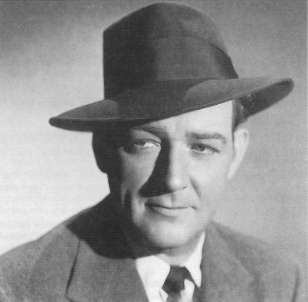
1 Bill Gargan

William Dennis Gargan was born on July 17th, 1905 in Brooklyn New York. He was a man that didn’t seem to waste time dreaming of what he wanted to do; He took his aspirations by the tail and diligently followed them down the path of decorated success. Determined to perform, and fresh out of high school, he pounded the pavement seeking a door of opportunity and landed on a well known road named “Broadway”. That famous place was not just a beginning but would always remain his first love. Not Broadway itself, of course but rather acting before a live audience.

At the very young age of 6 or 7 years old he had a bit part in an old silent film made at Vitagraph Studios, as a baseball player. He got paid $3.85 a day and became the envy of his friends. Growing up in that era found “Tiny Bill” doing the normal things one could expect. There were times that he and his friends would have serious rock fights against the Italian boys and get into other kinds of trouble. By the age of 13 he had worked many adventurous jobs including Ringling Brothers Circus and other odd jobs like wrapping gifts at a department store and even cleaning up an ice rink. It was at this time that the love of his life appeared. She skated right by him, so he followed after and literally swept her off her feet, or in this case, her skates. He knocked her down with the rink broom accidentally on purpose, if you know what I mean. Her name was Mary Kenny and would become his one and only girl until death parted them many years later.

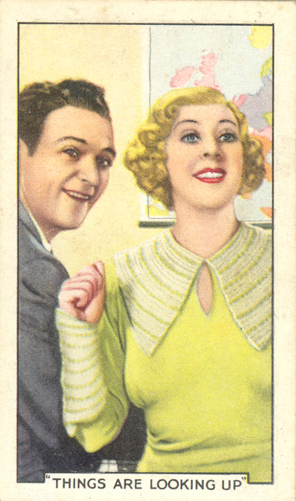

Gargan found ways to see plays even if he ditched school to do it. He was destined to act and eventually did so. He had parts in many plays and traveled around the country doing them. He was discovered by Hollywood for his work in a play called “The Animal Kingdom” in 1932 which led him to the west coast for a career on the silver screen, old time radio and television. He made several movies a year and got nominated for an Oscar as “Best Supporting Actor” for his work in a movie called, “They Knew What They Wanted” in 1940. By that time he was well known and had friends all over the industry.
This man loved his job and enjoyed life more than most people. It was evident to any who knew him that he was indeed a happy man. Life, for Bill, was a great time all the time. Whether he was acting with Carol Lombard, Joan Crawford or Myrna Loy, fishing with Bing Crosby, gallivanting around town with Spencer Tracy and Ralph Bellamy or helping JFK out a back alley to avoid the media—it was fun.

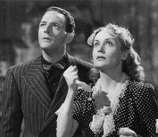
Figure 2 They Knew What They Wanted

The early years of entertainment for Gargan featured dozens of movies throughout the 1930’s, then suddenly we hear him in an episode of “Lux Radio Theater” in 1939 called ”One Way Passage”. After that the “Maxwell House Coffee” show had him penciled in for several weeks the first two months of 1940. From 1940-1946 he acted in nearly 40 movies under the old studio system. These would include the ever popular “The Bell’s of St. Mary’s”, “The Canterville Ghost”, and three Ellery Queen films done in 1942.

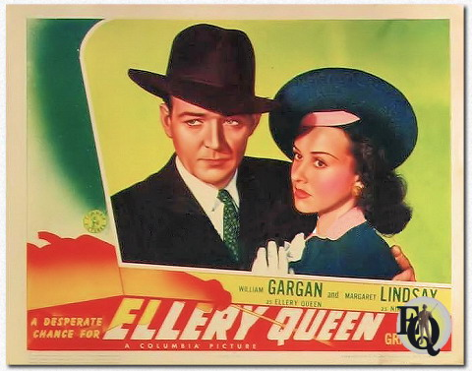

Gargan was a guy who became known as a worthy and notable detective. Whether it was radio, televison or the big screen, he did it well. As a matter of fact, he had a little experience as a real life detective for a brief period in his younger years and before that, followed and collected debts for a suit company where he once got shot at. That enlightenment was ever helpful when he played the likes of Ellery Queen, Ross Dolan, Martin Kane or Barrie Craig; for he made those characters believable with an ease other actors would long for.

On the radio, Gargan played a few parts in shows that had a brief run. The Blue Network came out with a sitcom called “Captain Flagg and Sergeant Quirt”, that ran from late September 1941 to late January 1942. It was about a pair of marines who engaged in constant conversational strife. Gargan read Sergeant Quirt’s lines in early 1942. There was controversy, however, when the lower ranked officer would be chewing out the captain. This, coupled with the recent attack on Pearl Harbor, did not bode well with real life marines. There was an attempt to re write the show with Quirt getting the boot and a new character being added, but it lasted only six weeks longer (Dunning).

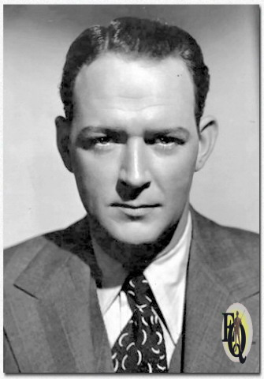

In January 1945, ABC’s west coast network birthed a mystery-quiz show called “Murder Will Out”, running until mid 1946. Gargan came along early in the show’s run to play Inspector Burke. The interesting gimmick here was that four contestants were chosen from the audience to participate and potentially win a $50.00 war bond and Gold Detective Certificate if they could guess who the killer was along with the correct clue. Another short lived show of Gargan’s was called “G.I. Laffs” which ran on CBS for two months in the summer of 1945. G.I’s would send in their gags to the show. Gargan was the host and Martha Mears did the singing on that one. Meanwhile we can see him continue making films through 1946 but slowing down some. Occasionally he would be on the radio in shows like “Command Performance”, ”Philco Radio Time”, “Family Theater”, or “Stars on Parade”.

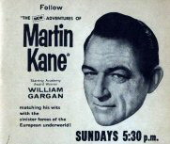

A detective drama called “I Deal In Crime” came about in very early 1946 with Bill as Ross Dolan. This show ran on ABC and lasted until the fall of 1946 with the stories being written by Ted Hediger. Later on we see Bill and Teds next adventure in 1949 as they teamed up for radios “Martin Kane, Private Eye”, on Mutual’s network. The radio show didn’t have a long run. Incidentally, the only circulating episode does not have Gargan in it, but by this time in his career, Gargan was a household name. Martin Kane saw Gargan on T.V. as the first real syndicated private detective show and if you tuned in Sunday afternoons, you could also hear him on the radio doing different “Kane” scripts.
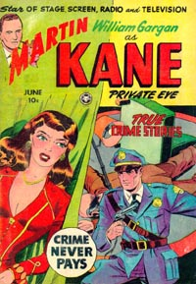

The Television show was a success-- so much so, that the BBC would later revive it in England under the title “The Return of Martin Kane”, however, there was a small problem or two with the original run of “Martin Kane, Private Eye”, according to Gargan himself. Apparently, the show was too short. The thirty minute programs were lacking in plot and proper character development due to time constraints. Another issue surfaced; the show began to feature pretty ladies, but they could not always remember their lines, and since the show was actually filmed live it began to falter. According to Gargan “They were blowing their lines all over the lot!” He went to the people in charge and asked for better scripts, to drop the pretty faces from the cast and get some pros or get another lead. He got canned and they got another lead…. then another, then another and finally a fourth before the show folded.

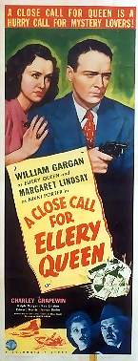

A few months later Gargan made an appearance on NBC’s Dr. Paul inviting listeners to turn the radio dial to a new show, “Barrie Craig, Confidential Investigator”, in which he plays the lead. Alongside him was one of radios consistent actors, Ralph Bell, who plays his second (Lt. Travis Rogers) with it being directed by the famous Himan Brown. This was another delightful detective drama that you wish would have lasted longer. Although Dunning seems to place this as “B” Grade, the show was solid in most ways with the writing being fine and the acting too as you could hear other well knowns like Santos Ortega and Parley Baer doing their just to the medium. Barrie Craig ran for about four years before ending in the summer of 1955. If you have these shows, they are a treat, as it’s the last radio series he did before having his larynx removed.

Between the Barrie Craig Run and The UK’s Return of Martin Kane in 1957-58, Gargan slowed down and enjoyed life with friends and family. You could see an occasional appearance in shows like “Pursuit”, “Studio One” or “The 20th Century Fox Hour” and he even made one movie in 1956 called “Miracle In The Rain”. Other than that he was living life as usual and having fun. In the spring of 1960 he was asked to play and ex president who was (Ironically) dying of cancer in a live play called “The Best Man”. He jumped at the chance as a couple of his oldest acting buddies were in the play. When the show began, Gargan started to lose his voice. At first he dismissed it as a minor issue but it would not go away and began to hurt. By his own Drs. request he saw a Laryngologist who discovered a cancerous growth in his throat. He recommended surgical intervention be done right away and just like that, William Dennis Gargan became a laryngectomee.

The emotions were high for him quite a while after the diagnosis and surgery. There was no guarantee that he would survive coupled with the realization that his career was over. No one would hear his voice as it once was. He tried to keep his chin up in front of others but by himself he would often cry. While he was in the hospital recovering from surgery he decided to go to the nurses station and get his mail. In his stuff was a new golfing book inscribed by his friend Clark Gable, encouraging him to get well. He went back to his room and laid down to rest, then turned on the news to discover that Gable had passed away. This scared him and his attitude was down as he realized how frail life was.

The support from his friends and family brought his spirits up and his sense of humor began to slowly return. He was given gifts that included several slates to write on as he could no longer speak. He got all sorts of them including one that was gold plated. Gargan called them his magic slates. At this time so many flowers were being delivered that he asked his wife to put a stop to it. He explained that laryngectomees could not smell anything. He went on to say that the flowers were beautiful, but he would prefer scotch. He loved Scotch!

After being discharged from the hospital he went home to learn a new way of communication called esophageal speech. When he went upstairs to his room he ran into the TV repairman who was fixing the television set for him. He had been a family friend for years and as he was tinkering with the set Gargan sat down. The squiggly lines disappeared from the screen only to be replaced by an image of Gargan speaking his lines in one of his old movies. The man’s face turned white as groped for the knob to turn it off and Gargan was faced with another depressing moment. His faith in God was the pillar of truth that held him up. He would often ask, “Why Me?”

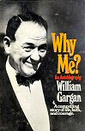
Figure 3 His Autobiography

It wasn’t too long after that when he began to meet others in the same situation as him and he became a figure of strength and hope to many. He became active in the fight to find a cure for cancer and began to put on benefits. Before long he was traveling all over the US giving speeches with his new voice and encouraging others to live their lives. He went from being an honorary chairman of a local cancer organization to speaking several times a year for the American Cancer Society. He was helping people and inside, was truly happy. He stopped asking God why and began to think “Why not, me?” The last years of Gargan’s life were the most fulfilling to him. He was the real deal, before the magic slate and after. William Gargan died in 1979 from a heart attack. He finished the race strong!

