Table of Contents
Dragnet in a sentence 1
The search for Premier missing episodes, 3/16/07: 2
Great Link to Music Origins 2
Newspaper Posting, Thursday, July 7, 1949 2
Dragnet TV Series 1951 through 2003 3
Dragnet (1951) 3
Dragnet (1967) 4
MCA Logo for Dragnet Movie 4
Dragnet (1989) 5
L.A. Dragnet 5
Biographies 5
Jack Webb 5
Jack Webb Trivia 9
Barton Yarborough 10
Dragnet in Library of Congress 10
Joe Friday's home address 10
Dragnet compared to Law and Order 11
Ray Anthony and Dragnet 13
Dragnet makes TV Guide 13
Dragnet Links Super site 14
Time Magazine Article – May 15, 1950 15
Time Magazine Cover and Article – May 15, 1950 16
Dragnet in the Comics 21
Jack Webb: The Man Who Makes Dragnet 21
Dragnet Reference in Mad Magazine 21
Dunning on Dragnet 22
Great Dragnet Internet Links 25
More About Jack Webb 27
Old Time Radio Digest Issue #76 29
Dragnet Return to TV 30
Badge 714 TV Shows 31

Dragnet in a sentence
FIRST BROADCAST: June 3rd 1949
LAST BROADCAST: February 26th
NUMBER of SHOWS: 382
SPONSORS: Fatima Cigarettes, Chesterfield Cigarettes
CAST: Jack Webb, Barton Yarborough
ANNOUNCERS: George Fenneman, Hal Gibney
PRODUCERS/DIRECTORS: Bill Rousseau
WRITERS: James E Moser, John Robinson, Frank Burt
SOUND EFFECTS: Bud Tollefson, Wayne Kenworthy
THEME: ‘Dragnet March’ by Walter Schumann
Dragnet – 1949-1957
Dragnet was a thirty-minute police drama featuring actual cases taken from the files of the Los Angeles Police Department. Jack Webb directed Dragnet and also played Detective Sergeant Joe Friday, the star of the show, who had remained a bachelor and still lived at home with his mother. It was one of the first radio shows to break the silence against dramatising sex crimes and child murders.

The search for Premier missing episodes, 3/16/07:
Letter to Mr. Don Aston from our member, David Oxford
"Hi. I am looking for the Dragnet broadcast of 6-3-49, which should be the first broadcast. I emailed Jay Hickerson who replied that you were the source of information in his 3rd Revised Ultimate History of Network Radio Programming - Book, page 130
I have not been able to find this episode. Does this episode actually exists and is it available? If so, how much does it cost? Episodes 10/6/49 through 11/17/49 are also missing. Do you have these episodes?
Reply from Mr. Don Aston,
"According to the MCA Log of Dragnet, and two other logs, there was a broadcast on 06-03-49. We thought we had located a copy many years ago, but it was never resolved. As of this date, there appears to have been a show, but we are of the opinion that it has never surfaced or maybe never existed. Yes the shows from 10-6 thru 11-17-49 are missing. I have not checked our archive in a long time. Maybe we have located one or two of those shows. I really doubt it. Even the repeat broadcasts do not help here. Be assured that if the shows were available we would or should have put them in circulation." …
Additional reply from Don Aston
I found this information after I replied to you. This is what I found years ago. As I said, whether it was ever aired is the question. We do not even have a script.
06-43-49 - Friday - The Writer was Robert Ryf - The Case was Robbery - "George Slocum-Thief is back"

Great Link to Music Origins

http://www.classicthemes.com/50sTVThemes/themePages/dragnet.html

Newspaper Posting, Thursday, July 7, 1949

Dragnet TV Series 1951 through 2003

Dragnet (1951)
Airs Next: NBC at Thursday 9:00 PM (30 min.)
Status: Ended Premiered: December 16, 1951 Last Aired: August 23, 1959
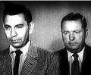
The program opened each week with these words from Detective Sgt. Joe Friday: "This is the city, Los Angeles, California. I work here, I carry a badge." Then that arresting theme music began to play ("Dum-de-dum-dum").Probably the most successful police drama in television history.
Dragnet's hallmark was its appearance of realism, from the documentary-style narration by Joe Friday, to the cases drawn from the files of the real L.A.P.D., to its attention to the details of police work ("It was 3:55. . .We were working the day watch out of homicide"). Viewers were reminded of the unglamorous dead ends and the constant interruptions of their private lives that plague real policemen, and this made the final shoot-out and capture of the criminal all the more exciting.
At the end of each episode, after the criminal was apprehended, an announcer would describe what happened at the subsequent trial and the severity of the sentence. The series was created and directed by Jack Webb himself. Its catchphrases and devices became national bywords and were widely satirized. There was Webb's terse "My name is Friday--I'm a cop," and "Just the facts, ma'am"
It was revived in 1967 as "Dragnet 1967" and again in 1989 as "The New Dragnet". This was followed by a short-lived revival in 2002 with Ed O' Neill as Joe Friday. The series was renamed "L.A. Dragnet" in 2003 and canceled shortly thereafter. A theatrical film in 1987 with Dan Aykroyd and Tom Hanks also surfaced. Other spin-offs included "Adam-12" (1968-75) and "Emergency" (1972-77).

Dragnet (1967)
Airs Next: NBC at Thursday 9:30 PM (30 min.)
Status: Ended Premiered: January 12, 1967 Last Aired: April 16, 1970
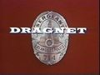
Dragnet 1967-1970 was the second run of the Dragnet series. It began in January of 1967, and ran to September of 1970. The lead character, Sgt. Joe Friday, was played by Jack Webb, who also directed and produced the series. The show's focus is on two detectives, Sgt. Joe Friday, and Officer Bill Gannon, played by Harry Morgan. The two track down criminals all throughout the city of Los Angeles, California.
The original "Dragnet" was the grandfather of ALL of today's police drama shows. This was the first time a cancelled network TV series was successfully revived.
In late 1965, Universal and NBC hired Webb to revive "Dragnet" as a made-for-TV movie. This was filmed in early 1966, but didn't air until January 1969. Titled "World Premiere: Dragnet," the well-made film has Friday and Gannon linking the slayings of photographer's models to the disappearance of a war widow, while Gannon prepares to retire.

MCA Logo for Dragnet Movie
2nd Logo (1964-1969)
Nickname: "Zooming Globe 1"
Logo: Like its then current movie logo, the rotating globe zooms in on us. The phrase
FILMED AT THE STUDIOS OF
UNIVERSAL
CITY
MCA-TV Exclusive Distributor
is superimposed simultaneously. The text will usually appear in the normal near-yellow font, but a bronze/brown color appears sometimes. The MCA union bug appears with the byline.
Variations: On some shows, the MCA byline is not present below the Universal City name. This happens on most co-productions, notably Mark VII shows. Other shows (mainly those produced by Jack Webb's Mark VII, like Dragnet) would have a shot over the globe saying "IN ASSOCIATION WITH UNIVERSAL TELEVISION" centered in the same font used in the closing credits. This text would then fade out, the globe would zoom and appear as usual. On Dragnet '67, the "Universal Television" text was not shown.
FX: The zooming in of the globe.
Music: A slightly abridged version of the Revue jingle. There are several orchestrations of this theme. A list is hopefully coming soon.
Availability: Can be found in shows like Dragnet, Adam 12, The Munsters, and McHale's Navy, as Universal's past logos are kept quite well.
Scare Factor: Median, mainly based on what you think of that somewhat scary Revue theme.

Dragnet (1989)
Originally on: Syndicated (30 min.)
Status: Ended Premiered: October 1, 1989 Last Aired: September 1, 1990
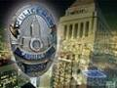
Dragnet (1989) was a syndicated revival of the classic Dragnet (1951) and Dragnet (1967) series, which were based on the 1949 radio drama, all of which starred Jack Webb as LAPD detective Joe Friday. Webb died in 1982, however, and this revival decided not to re-cast his famous character. Instead, the 1989-1990 series, also known as Dragnet: The '90s or The New Dragnet, starred two younger detectives, but kept to the original formula of voice-over narration and sticking to "just the facts". Though 52 half-hour episodes were made, this series has generally faded from public memory, likely due to the lack of Joe Friday's distinctive character and also to the success of shows like Cops and police dramas such as Hill Street Blues and NYPD Blue.
This series had no relation to the 1987 comedic film version of Dragnet.
NOTE: IMDB shows a release date for the series as October 4, 1989, and lists the episode "The Payback" as airing on October 11, 1989. However, copyright registration records list the earliest publication date as October 24, 1989. Copyright registration publication dates are being used.

L.A. Dragnet
Airs Next: ABC at Sunday 10:00 PM (60 min.)
Status: Ended Premiered: February 2, 2003 Last Aired: May 26, 2004
Episodes: 20 aired. 2 unaired
From Emmy Award-winning producer Dick Wolf, one of television's most successful creators and architect of the long-running Law & Order franchise, comes this modern-day take on the classic police drama. Filmed on locations throughout Los Angeles, this updated version of "Dragnet" features a group of detectives in the LAPD Robbery/Homicide Squad investigating crimes that could only take place in Los Angeles, one of the world's most glamorous and intriguing cities.
Within this incredibly diverse landscape, these dedicated cops are relentless when it comes to solving crime. Lieutenant Joe Friday (Ed O'Neill) is a seasoned veteran who has seen it all. Through his voiceovers, viewers will gain insight into the crime investigation process, as well as hear the honest thoughts of a 21st century cop. Although a veteran of the beat, Friday still has the same passion and energy as his younger charges.
Dragnet will draw storylines from L.A.'s rich crime history, as well as today's headlines. Against the backdrop of economically and culturally diverse neighborhoods, the detectives come up against a group of criminals who are just as diverse, from diamond thieves and Hollywood movie moguls to street gangs, copycat serial killers, international terrorists and kidnappers.
Adding a contemporary look to the show is the introduction of a radio-controlled miniature helicopter known as the Flying-Cam, which will provide panoramic views from never-before-seen angles of L.A.'s many neighborhoods. In addition, video technology will also feature prominently in a number of episodes, reflecting society's obsession with the "big brother" world of present day security.
Dragnet began in 1949 as a radio drama, then moved to television in 1952, running for seven years in its initial incarnation. It resurfaced in 1967 for three more years, starring Jack Webb as the no-nonsense, "just the facts, ma'am" LAPD Sergeant.

Biographies

Jack Webb
Jack Webb Radio Bio
By Mike Thomas

“The Big Webb”

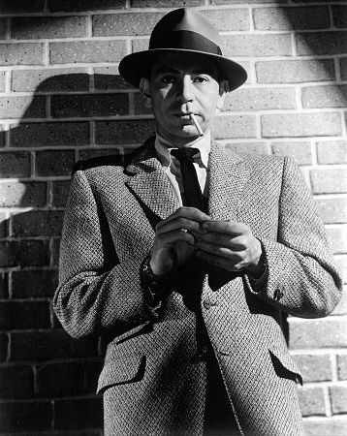

His real name was not Joe Friday, nor was it Pat, Jeff, Pete, Buzz-saw Louie or even Jack. He was born John Randolph Webb on April 2nd 1920 in Santa Monica California with a special gift that would be discovered later on and enjoyed for many years. One of the West Coast’s most consistent and sought after radio actors of that age, Mr. Webb could do many things, and do them well. Since his illustrious career is longer than my left leg, we shall focus mainly on his old time radio accomplishments where “Jack” (the name he went by) left his legacy.

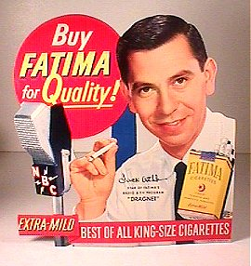

Jack Webb Served in WWII and started out in radio as a disc jockey before hosting, and acting in hundreds of old time radio shows. He had talent to be reckoned with and far off dreams of directing that eventually came to fruition in his well decorated career. His pedigree goes way back to the golden age of radio where it made its’ permanent gold mark before moving on to the medium that seemed to rudely push radio aside—namely television. Between radio shows he acted in old movies and eventually starred as Joe Friday on the famous television version of Dragnet. Webb ran the gamut of acting, producing and even directing-- fulfilling his dreams of old.

The spring of 1946 saw him doing several different shows from the West Coast on ABC. One of these was a Comedy-Variety program called “The Jack Webb Show”. Some People may not readily associate him with a funny show but this one had all the makings of a silly stage cast with the closing signature by Webb-“ Tonight’s egg was laid on the vocal side by Clancy Hayes and Nora McNamara. John Galbraith blew the lines and Dick Breen glued the joints together” (Dunning). The only apparent surviving episodes are full of fun and worth the listen. About the same time we can hear him with another type of script and on another stage—a stage with drama all over it. The show was a dramatic anthology called “Spotlight Playhouse”, and unfortunately has only a couple episodes in circulation. Both of these shows featured music and score by Phil Bovero. Another ABC drama called “Are These Our Children?” which originated out of San Francisco, aired an episode in November 1946 named “Edith Hayes” which had the expertise of Mr. Webb in the credits.

Before these shows though we can hear Jack showcase his talent in a documentary drama called “One Out Of Seven”. Each story for the show was chosen from actual news that happened the past week. Hence one story from the past seven days was picked; the scripts were fleshed out by James Edward Moser. This particular program stood up for what was right and hailed a voice that would not stand for racial prejudice. Jack Webb’s genius was proven as he played all roles and characters for this show and seemed to do them with such effortless ease. Jack Webb would be pro early on in his career.
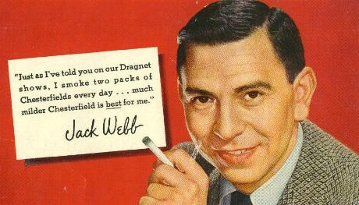

There were other shows that capitalized on Jack Webb’s ability in his early years in radio. The Red Cross had a syndicated 15 minute drama called “Errand of Mercy” that ran in the 1948-1949 timeframe with Jack in the line-up. At the same time the Treasury Department ran a syndicated show called “Guest Star” that penciled Jack in a handful of roles. On at least one occasion we see the episode date of these two shows with Jack’s name in the credits on the same exact day.

Jack soon became “Pat Novak, For Hire”, which ran on the west coast only circa 1946-47 on ABC. This was a crime drama that slapped a persona on Webb that would follow him for a long time in Radio. He was a tough, clever and quick witted detective full of one liners. You have to love this guy—just listening to him think will bring many laughs and much enjoyment. Even when a gun is pointed at him, the calm one liners flowed like a river after a big rain. Jack left the show and moved south, but since Pat Novak was so popular, the network re-cast that show and kept it on with a new lead and script writer. The show resurfaced in February 1949 nationwide with Webb back in old form.

After Jack left San Francisco for Hollywood, a new Detective adventure show began called “Johnny Madero, Pier 23”, which ran on Mutual from April through September 1947. This show is entertaining and reminds me of Phillip Marlowe in its descriptive writing style. Among the many quips you will here Johnny say are “Your so scary, I bet your dandruff stands on end” , “You couldn’t clear your throat in an empty tunnel”, “Some days your not gonna make out better than an ice cube at a cocktail party”, and ” Breaking more records than a disc jockey with a hangover”. This show had Gale Gordon and William Conrad in it with a familiar name writing the scripts—Richard Breen. Richard and Jack had worked together on most of his shows to this point. They (Breen and Webb) wanted to continue with Pat Novak but it was being carried on up north by Ben Morris and Gil Doud, so apparently, as the story goes, they started the Johnny Modero, Pier 23 show in the same spirit as Novak.(Dunning)

Jack frequently starred in many popular mystery and drama series like Escape, Suspense, and The Whistler, doing his thing in these series dozens of times. He was a busy guy that anyone would want on their cast. By 1948 you could see his name in the credits on “The New Adventures of Michael Shayne” before his debut as “Jeff Regan, Investigator”. By the time Regan aired, Jack Webb had a following of people who missed the Pat Novak days and wanted to hear Jack on the air again. “Jeff Regan, Investigator” was Webb’s third detective show before Dragnet’s creation and had a lot going for it from the get go. Even though this show was different than Webb’s previous detective characters, it did have a very prolific script writer in E. Jack Neuman and ran on CBS.

There were other ventures that Jack Webb had his hands in. Command Radio Productions hatched an idea for a show called “Three For Adventure” that had Elliot Lewis, Barton Yarborough and Jack Webb starring in the audition. This was to be an adventure series that apparently had the likeness of Carlton E. Morse’s famous “I Love a Mystery” series. As to what became of that program, the author has no idea but the audition show does exist. Other crime dramas in the “40’s” that had Jack in a role, were “Ellery Queen”, “The Adventures of Sam Spade” and the “Murder and Mr. Malone” series (which is also known by three other names).

In 1948 he starred in a movie called “He Walked By Night”, playing a crime lab police officer. It was on that set where he met sergeant Marty Wynn of the LA Police who happened to be the films technical adviser. As they discussed various aspects of investigative procedure and melodrama the idea for Dragnet was sown in the head of Jack Webb. He thought about creating the show with realism at the core and the stories to be authentic in every sense, using genuine police files. At that point Jack began hanging out with the police, attending classes at the police academy and riding along with them on calls. “Dragnet”, began its steady march of the airwaves in June 1949 and ran until February 1957. This would be Webb’s Magnum Opus in radio and followed into a more than one television series. Jack Webb played Detective Sergeant Joe Friday of The Los Angeles Police Dept. and also directed the series.
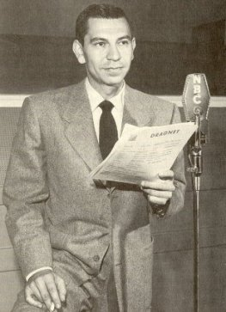

When the time came to pitch the show to NBC, they were unimpressed, thinking it would be just another cop show (Dunning). Webb went to the LA Police for help. He pitched the idea to them as well, wanting the stories to be real and from authentic files (with names being changed of course). Jack was a detailed professional and wanted nothing less than perfection on this one. The police approved and the show was successful beyond any other detective show in history. It won the coveted “Edgar” award for best drama two years in a row (1951-52) by the Mystery Writers of America and would forever be a show to be remembered. No other old time radio show could share the same repeat winning credits as this awarded program did.

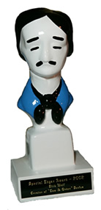
By the time the 50’s rolled around, “Dragnet” was a household name and the desire for Jacks Services was as strong as ever. He played a cynical police lieutenant in an episode of “The Story of Dr. Kildare”, along-side the great Lionel Barrymore, and also spot starred in classic shows like “Nightbeat”, and “Family Theater” and can even be heard in a show named “Proudly We Hail” circa 1952. His voice was on many channels during the prime of his career.

Two some odd years after Dragnet became a hit, Richard Breen created a new show called “Pete Kelly’s Blues” with Jack as the lead, and ran for 12 weeks on NBC. This show was set in the roaring twenties and featured Jack Webb as a cornet player in a speak-easy in Kansas City. The writing was similar to his old detective characters in some ways as he thinks much the same way and the language in his head sounds oh so familiar. The setting and music theme seemed to be its biggest charm and even led to a film of the same name in 1955 played by—you guessed it—Jack Webb. Fortunately most of this show’s run has been saved and is very enjoyable.

Jack Webb was not only an American, but also a patriot who loved his country. Many times he would do specials that would reflect these beliefs. In July 1957 he did the Fifth Anniversary Salute of “Operation Skywatch” which featured the U.S. Air Force Band. Another special, “Hollywood Salutes the National Guard” which was done in February 1959 had his help as well. The Air Force reserve had a syndicated show called “Weekend Sound Flights’63”, that had Jack as the announcer for at least three consecutive shows in 1963 and to round off things, he did a show on Mutual in 1969 called “Special Delivery: Vietnam”.

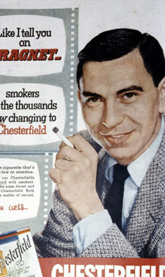

The list of credits goes on of course. Lots of celebrities had Jack on their shows throughout his acting tenure. From Bob Hope, Martin & Lewis and even to Jack Benny’s second farewell special in 1974, we can see that Jack Webb was respected and loved by fans and famous folks as well. He was nominated for an Emmy four times, authored a book and has his own star on the Hollywood walk of fame. He passed away in December 1982 but much of his work is preserved and enjoyed to this day. Jack Webb lives on!

Jack Webb Trivia
Webb is buried in the Forest Lawn Hollywood Hills Cemetery in Los Angeles.
Webb's personal politics were very conservative and this was reflected in the tone of his shows.
Webb's character, Sgt. Joe Friday, never said, "Just the facts, ma'am."
Webb briefly served as head of production for the TV unit of Warner Brothers in 1962.
Webb directed and co-starred with Robert Mitchum in the 1961 film The Last Time I Saw Archie.
Webb's life was the subject of an episode of Biography on A&E.
Webb won critical acclaim for his portrayal of a hard core Marine Corps Drill Instructor in the 1957 film The D.I.
Webb had two daughters with first wife Julie London: Stacey and Alisa.
Jack Webb refers to his hobby of collecting early jazz records.
Webb was nominated for Emmys for Dragnet from 1953-56 but never won.
Webb has a star on the Hollywood Walk of Fame located at 6250 Hollywood Boulevard.
Webb was married four times:
Julie London (1947-53), Dorothy Towne (1955-57)
Jackie Loughery (1958-64), Opal Wright (1980-his death)

Webb was the basis for the character of Brett Chase in the 1997 film L. A. Confidential.
Webb was offered the role of Dean Wormer on Animal House but turned it down.
Webb smoked three packs of cigarettes a day.
Webb never knew his father and was raised by his mother and maternal grandmother.
Webb's production company was named Mark VII.
In 1968, Webb parodied his Joe Friday persona in a hilarious Tonight Show skit with Johnny Carson.
At the time of his death Webb was considering reviving Dragnet with Kent McCord as his partner.
The LAPD named a police academy auditorium after Webb.
Webb cast ex-wife Julie London and her current husband, Bobby Troup, in his 1972-77 series Emergency!
Webb's second version of Dragnet lasted from 1967 to 1970. That series was a bigger hit in syndication than first run.
In 1951, Webb took Dragnet from radio to television. The series lasted until 1959.
Webb played William Holden's best friend in the classic film Sunset Boulevard.
Webb co-starred with Marlon Brando in 1950's The Men which was also Brando's film debut.
In 1950, Webb co-starred with future Dragnet partner Harry Morgan in Dark City. That film also marked the movie debut of Charlton Heston.
The radio version of Dragnet premiered on 1949 on NBC with Webb as Joe Friday and Barton Yarborough as Ben Romero.
Webb's work on the 1948 film He Walked by Night gave him the idea for Dragnet.
Webb starred in a radio drama, Pat Novak for Hire, after leaving the service.
Webb served as a crew member of a B-26 Marauder during World War II.
Webb grew up in the Bunker Hill section of Los Angeles.
He was 5 feet 10 inches tall.
Upon his death, the badge number 714, used by his character Sgt. Joe Friday in Dragnet was officially retired by the Los Angeles Police Department.
Performed charity work related to widows and orphans of police officers killed in the line of duty.
He was buried with full honors befitting a LAPD detective, including a 17-gun salute.
Actor, producer, and writer who became a TV legend with the premiere of the police procedural drama Dragnet in 1951. Though he had a solid film career appearing in movies like Sunset Boulevard and The Men, it is for Dragnet and other Webb productions such as Adam-12 and Emergency! that he is most remembered. So identified was Webb with his Dragnet character, Joe Friday, that Friday's badge number, 714, was officially retired by the LAPD upon his death.
Jack had just over 6,000 jazz albums in his private collection.

Barton Yarborough

In the Dragnet Episodic Log, there is a note saying that this was Barton Yarborough's next-to-last appearance on the program. From “Barton Yarborough’s Biography” by Bob Siler (http://www.badge714.com/dragbart.htm):

This was to be Barton Yarborough's 133rd appearance as Sgt. Ben Romero. It was also his last. They started in Homicide and they ended in Homicide. The show that aired the following week, on December 20, was a repeat of their Christmas show -"22 RIFLE FOR CHRISTMAS".

This seems to imply that the broadcast of “22 Rifle For Christmas” was actually a repeat broadcast, and that “The Big Overtime” was actually his last new broadcast. Can we confirm if “22 Rifle” was a re-use of the script, or simply a re-airing of a previous broadcast?

Dragnet in Library of Congress
There are 108 episodes of the Dragnet radio series cataloged in the Library of Congress.
http://lcweb5.loc.gov/cgi-bin/starfinder/1380544/sonic.txt

Joe Friday's home address
That address currently belongs to a custom design company called 4656 DesignHaus. They are aware that they are at the Dragnet address.
http://www.4656.com/haus.asp
http://tinyurl.com/2mzjz5

The map attachment is for 4656 Collis Ave., exists in South Pasadena
(considered part of Los Angeles).

Dragnet compared to Law and Order

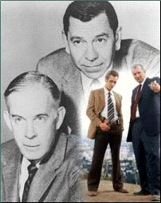
The article you're about to read is true. No names have been changed to protect the innocent--or the guilty, for that matter.

Recently, Dick Wolf--the creator of the "Law & Order" series--told "The New York Times" about his decision to revive a classic police procedural for the new millennium: "I sure as hell don't want to be known as the producer who screwed up 'Dragnet'". And he had good reason to worry. "Dragnet" became the most-popular police drama in U.S. history, in part because it brought a new realism to the genre. Until "Dragnet", police shows hinged on a successful conclusion through good luck, larger-than-life characters or a lucky break. "Dragnet" showed what typical cops did every day--question suspects and witnesses, examine evidence, and slowly but surely come up with the information needed to bring a suspect in. "Dragnet's" realism was helped by the fact its stories were based on real-life cases from the Los Angeles Police Department. A three-person panel provided the cases; the names and situations were changed for broadcast. The use of actual situations helped give the show a documentary look, enhancing the realism.

"Dragnet" was also unusual for a police drama in that it did not delve deeply into the personal life of its main character, Sgt. Joe Friday, played with determined seriousness by the late Jack Webb. (We knew he was single and occasionally dated; any woman who thought about getting serious with Joe knew she would play second fiddle to his law enforcement career.) And it was unusual for its lack of violence. Webb, the former clothing store clerk-turned actor, producer and director of "Dragnet" noted that there were only 15 gunshots and three brawls in the first 60 TV episodes.

Webb portrayed Friday in three different versions, including the radio show that began in June 1949 on NBC. Initially unsponsored (and lacking support from network executives), critical praise and word-of-mouth eventually made "Dragnet" a radio hit and helped the show land a sponsor (Liggett & Myers Tobacco, which made Chesterfield cigarettes). The radio version ran until 1957.

NBC was interested in bringing "Dragnet" to television, and Webb was ready to shift focus to a video version. NBC wanted a live show from New York; Webb wanted to film "Dragnet" in Los Angeles (a battle not unlike Lucille Ball and Desi Arnaz waged with CBS over "I Love Lucy"). But Liggett & Myers pressured NBC to compromise and do it Webb's way. The pilot "The Human Bomb", which featured a man who threatened to blow up Los Angeles to get his brother out of jail, aired as an episode of Chesterfield's short-lived variety program "Sound-Off Time" on December 16th, 1951. (The pilot featured a pre-"Perry Mason" Raymond Burr as Friday's superior.)

With sponsorship from Chesterfield, "Dragnet" became a regular series in January 1952. At the time, Webb's production company Mark VII could not make enough episodes for weekly airing, so NBC and Chesterfield aired the television version of the radio classic "Gangbusters" on alternate weeks. Despite the fact "Gangbusters" ranked 8th in the Nielsens overall, it was cancelled in December 1952--probably the highest-rated series ever to get the ax. Apparently, "Gangbusters" was designed to air only until Webb could provide new "Dragnet" episodes on a weekly basis. By the 1952-53 season, "Dragnet" was the fourth highest-rated program on television. A year later, it went to #2, right behind CBS' formidable "I Love Lucy". And both shows signaled the rise of filmed television series in the US; the live program would be almost a memory by the end of the decade.

Friday's first partner was Sgt. Ben Romero, played by actor Barton Yarborough on the 1951 pilot. But Yarborough died a few days after the broadcast, forcing Webb to search for a new partner when the series began. Barney Phillips was Sgt. Ed Jacobs, followed by Herb Ellis as Officer Frank Smith. In 1953, the Smith character remained, but Ben Alexander replaced Ellis in the role.

Another distinction of "Dragnet" was its theme. Walter Schumann wrote the music, known also as the "Dragnet March" and "Danger Ahead". (Most folks know it by the first four notes: Dum-de-dum-dum.) Bandleader Ray Anthony took his version to #3 on the American music charts in 1953. But a parody of "Dragnet" also did well. Composed and written by satirist Stan Freberg, it was called "St. George and the Dragonet" ("The story you are about to hear is true, only the needle should be changed to protect the record."). "Dragonet" sold over a million copies.

The success of "Dragnet" led to similar shows as "The Lineup" and "M Squad". But by the late 1950's, programs such as "77 Sunset Strip" and "Peter Gunn" became the "anti-'Dragnet'" by focusing on the glamour and sex appeal of crime fighting, instead of the nuts and bolts--along with a good dose of violence. In this climate, "Dragnet" had become old hat for viewers and was cancelled by NBC in 1959. But the black-and-white reruns continued to live on, renamed "Badge 714" for syndication.

In 1966, Webb produced a new made-for-television "Dragnet" movie. NBC loved the result so much, the network ordered a new "Dragnet" series to begin airing the following year. Ben Alexander couldn't join Webb in the remake; he was already doing his own police drama "Felony Squad" on rival ABC. So the TV film gave Joe Friday a new sidekick: Veteran actor Harry Morgan, who was at the time best-known for his role in the 1950's sitcom "December Bride" and its spin-off series "Pete & Gladys". became Officer Bill Gannon. Ironically, the TV movie didn't air until 1969, but the new series--entitled "Dragnet 1967"--made its debut on January 12th of that year with an episode entitled "The LSD Story". (Fans know it better as "Blue Boy" because of the main character, Benjie Carver, who got his nickname because part of his face is painted blue.) The new "Dragnet", now in living color, stuck to the formula that made the original popular, but leaned quite heavily on an anti-drug message and teenagers in trouble. (Those episodes always seemed to have wayward teens and parents telling Friday and Gannon: "No! Not my child! He doesn't use drugs!" And more often than not, the parent/user got a stern anti-drug message from Friday.) The new "Dragnet" also led to a spin-off of its own. In 1968, NBC premiered "Adam 12", featuring a pair of beat cops in the "Dragnet" formula of relatively little violence and cases pulled from the LAPD; it ran for seven seasons. Other Webb-produced shows of the late 1960's and 1970's included "Emergency!"; "O'Hara: US Treasury"; and "Project UFO".

The second generation color "Dragnet" ran until 1970 and still runs on many a television station (unlike the black and white episodes). By the 1980's, however, new wave police dramas such as "Hill Street Blues" and "Cagney & Lacey" began to make "Dragnet" look old-fashioned--and in some quarters, even parodies of police drama. (Jack Webb himself died of a heart attack in 1982.) In 1987, Universal Studios released a film version of "Dragnet", with Dan Aykroyd as Joe Friday and Tom Hanks as his scruffy partner Pep Streebeck. Unlike a 1954 "Dragnet" film (which was largely based on the TV series and is seldom seen today), the new "Dragnet" movie was played for laughs. Harry Morgan--now better-known to TV viewers as Col. Sherman Potter on M*A*S*H--appeared in the film as Bill Gannon, with a promotion to captain. And Aykroyd's portrayal of Friday was dead-on. But the script was weak and loaded with drug and sex references that did neither Aykroyd nor Hanks any favors. Still, the "Dragnet" name did ensure a large audience at the box office and led to more films based on TV series.

In 1989, a syndicated version of "Dragnet" aired on local television stations in the US. Jeff Osterhage played Vic Daniels; Bernard White was his partner Carl Molina. It died in 1990 after a run of just 52 episodes.

Which leads me to the new "Dragnet". While he didn't want to be known as the producer who damaged a classic, Dick Wolf recently told reporters that "nobody under 35 has ever seen "Dragnet", unless they're stoned watching TV Land at 3 in the morning". But he noted that he had to walk a thin line: "Part of the mandate I had is if you're going to do it, the older audience had to find a show that signaled 'Well, OK, that's cool, that's 'Dragnet'. But the younger audience had to get a cop show that was really different." With his "Law & Order" trio for NBC (the original and spin-offs "Special Victims Unit" and "Criminal Intent"), Wolf has proven to be a master at doing straightforward stories. As a result, the new "Dragnet" is not unlike "Law & Order", with some elements of the old series thrown in (a more stylish version of the classic Schumann theme updated by Mike Post; and the voiceover by Joe Friday). This time around, Friday is being played by Ed O'Neill, a dramatic actor who is still better-known for comedy--specifically, the hapless shoe salesman and husband Al Bundy on the sitcom "Married With Children".

In my review for Television Heaven (Teletronic's sister publication), I wrote that "O'Neill is an effective Friday, enough to make you forget that once upon a time, he was Al Bundy..." Appearing as his partner is Ethan Embry as the younger, sarcastic Frank Smith--a far cry from Harry Morgan's grandfatherly Bill Gannon. The pilot episode was also light years from the "Dragnet" of old. Jack Webb would have been shocked to see Friday and Smith discuss gory "CSI"-like amputations of body parts; and the exclamation by Smith when semen is found on the genitalia of a female murder victim: "Premature ejaculation--we've got a squirter!" (The old Friday and Gannon would have kept that information to themselves.) The same episode also featured a fan of serial killer memorabilia, who showed the cops a scar from a prostate operation and tells them he could not have raped and attacked several women because the operation left him impotent. (Come to think of it, you can probably get the same sexual information on an episode of "Friends". But that's another story.)

The new "Dragnet" is a well-produced, well-written, well-acted police drama. And that's the rub. American television is currently filled with good police dramas. The two "CSI" shows look at crime from a scientific point of view; the veteran "NYPD Blue" deals with the relationships among members of a detective squad; "The Shield" blends good cops and bad cops together in a satisfying mix; and freshman series "Boomtown" looks at the same crime through different eyes. By contrast, Wolf's latest creation comes off as yet another "Law & Order" spin-off--nice to look at and watch, but with few twists to set it from the crowd. That may be the difference between a second season or cancellation. But that familiarity could be just fine with viewers.

Whatever the future lies for the new "Dragnet", the old series' place in television history is secure. And so is the legacy of Jack Webb, who brought us one of the most memorable fictional TV characters ever.

Pasted from <http://www.teletronic.co.uk/dragnet.htm>

Ray Anthony and Dragnet

Apparently, in 1953, Ray Anthony had a hit song based on the theme for Dragnet. It starts out with the standard opening, and then moves into a very jazzy middle bit that finally ends on the good old da-da-da-dum. Apparently it went to #2 on the U.S. charts and #7 on the U.K. charts. A copy of this arrangement is provided in the supplemental folder.

Dragnet makes TV Guide

(See cover samples below)

This is sort of interesting because TV Guide's first issue was in early April of 1953 and the first mention I can find on a cover with Jack Webb or anything to do with Dragnet is:

December 11-17 Issue #37 Dragnet's Jack Webb cover

TV DIGEST (Pittsburgh & Tri-States Edition) TDPT 530321

cover: MARILYN MONROE other articles: Dragnet Mar.21-27,1953 $209.00

TV-RADIO LIFE (Los Angeles) TVRL 530425

cover: JACK WEBB OF "DRAGNET" other articles: Who has the prettiest legs on TV, Will 3-D TV Come? Apr.25-May 1,1953 $31.00

TV DIGEST (Pittsburgh & Tri-States Edition) TDPT 530523

cover: ELAINE STEWART other articles: Dragnet May 23-29,1953 $9.00

TV GUIDE (U.S.) TVG 0037

cover: JACK WEBB OF 'DRAGNET' other articles: Jungle Jim, Ramar of Jungle

Dec.11-17,1953

TV Guide - The First Year 1953

The very scarce first national distribution year of TV Guide. All issues are in fine or better condition unless noted. Click on links to view selected covers. December 11-17 Issue #37 Dragnet's Jack Webb cover, Jungle Jim. Ramar of the Jungle (Stock number 003tvg37) $25.00

Pasted from <http://www.the-forum.com/ephemera/tvguide1.htm>

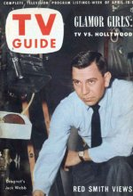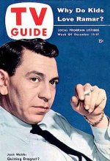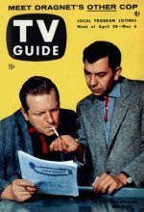

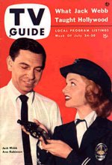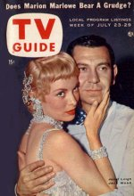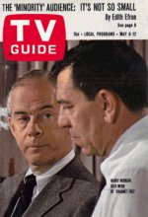

Dragnet Links Super site

http://www.timstvshowcase.com/dragnet.html

Time Magazine Article – May 15, 1950

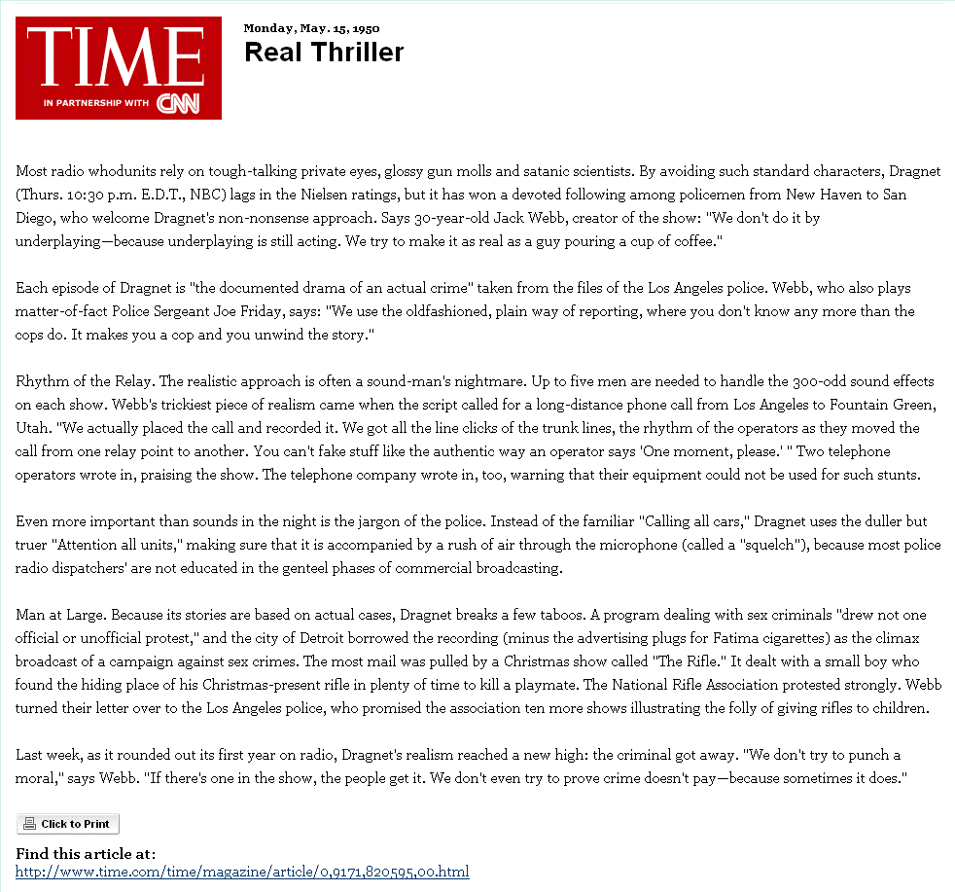

Time Magazine Cover and Article – May 15, 1950
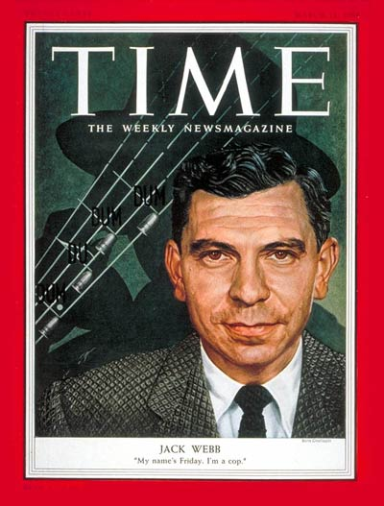
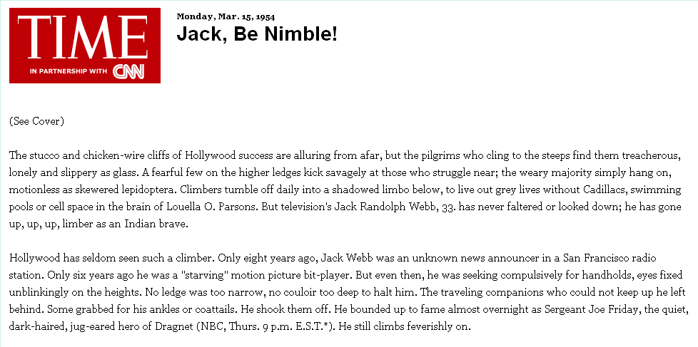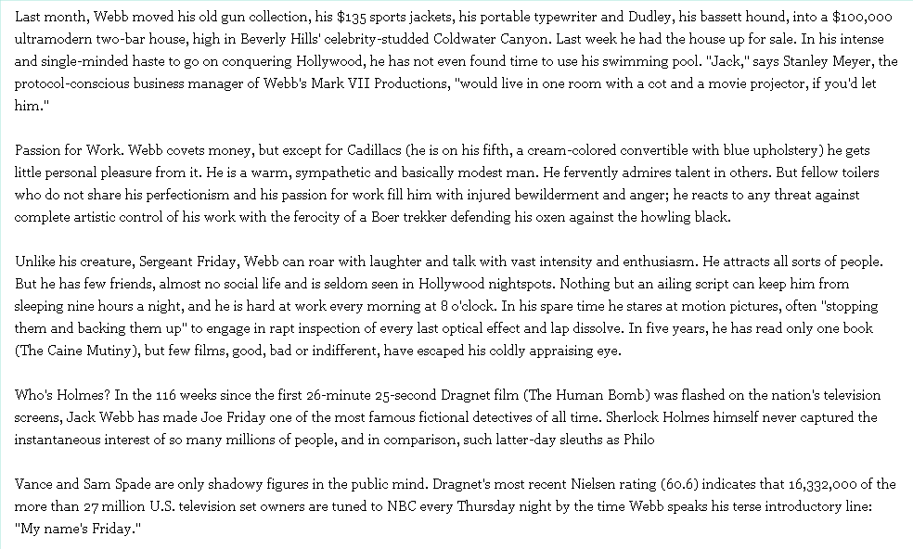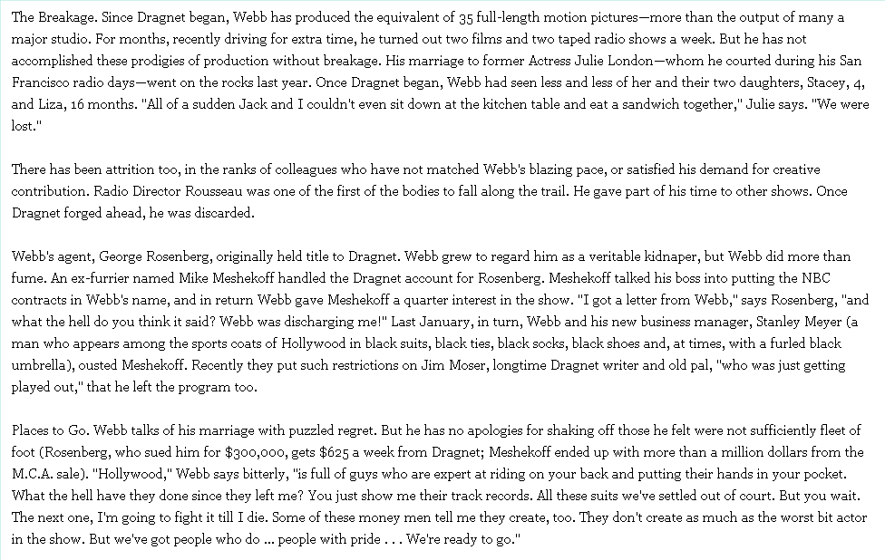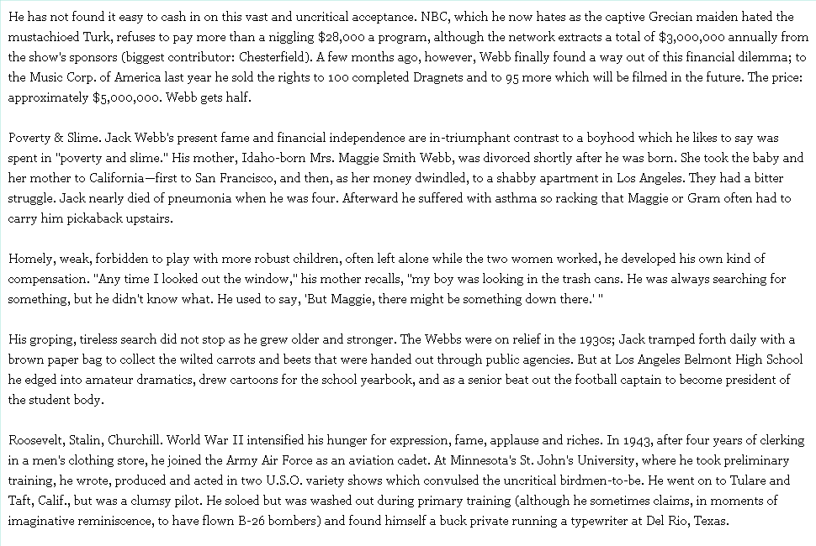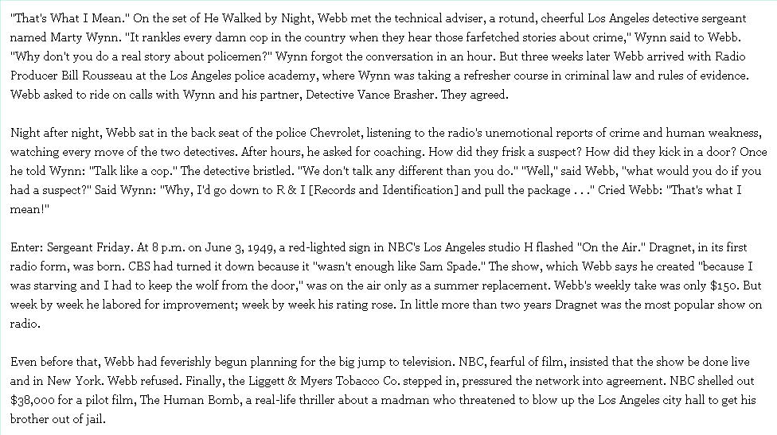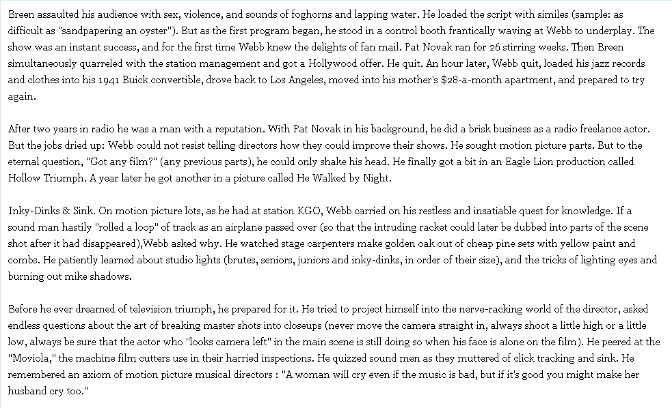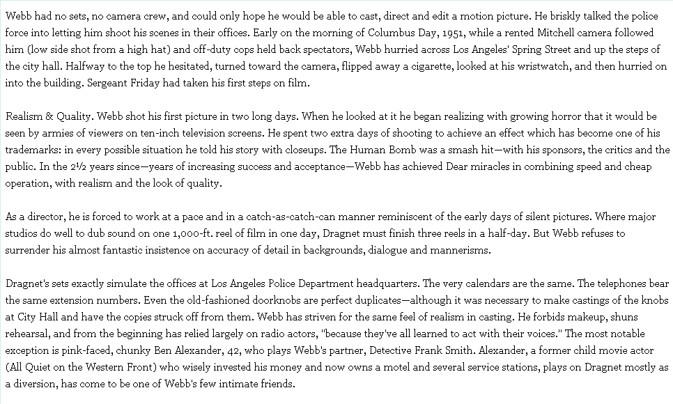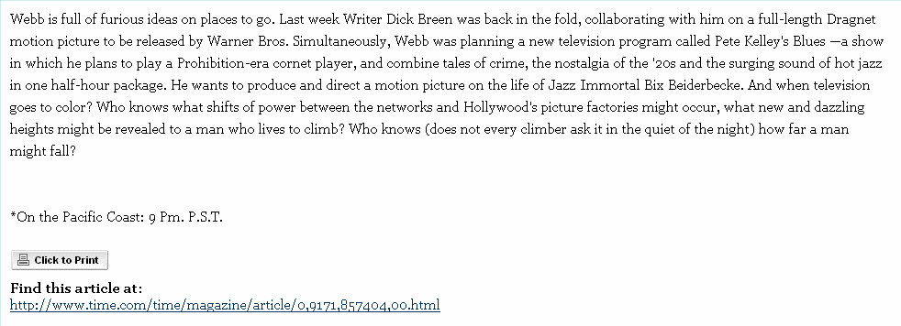
http://www.time.com/time/magazine/article/0.9171.857404.00.html

Dragnet in the Comics
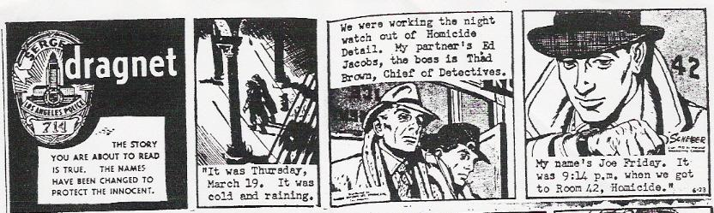

The series had been on radio 3 years when the strip debuted on June 23, 1952, but the TV version had only been on for six months - and airing every other week, to boot. The strip faded away sometime in 1955.

Several more strips and detailed instructions for finding more can be found at the link:
http://betterlivingtv.blogspot.com/2006/06/just-funnies-maam.html

Jack Webb: The Man Who Makes Dragnet
(from Coronet Magazine, September 1953) http://www.badge714.com/coronet.htm
Provides another perspective on the formula that makes the program a success.

Dragnet Reference in Mad Magazine
Police.
"Dragged Net!" / art: W. Elder. in Mad, no. 3 (Feb.-March 1953) -- Notes: TV shows, Dragnet, police. -- Data from index in Mad #350 -- Reprint call no.: PN6728.2.E15M3a 1986 | "Dragged Net!" (Dep't: Crime) / art: W. Elder. in Mad, no. 11 (May 1954) -- Notes: TV Shows, Dragnet, police. -- Data from index in Mad #350 -- Reprint call no.: PN6728.2.E15M3a 1986

Dunning on Dragnet

Dragnet, police drama; a pioneering series of unprecedented realism.

Broadcast History: June 3, 1949-Feb 26, 1957, NBC. 30m, various times on the first four months; 1949-1950, Thursdays at 10:30, Fatima Cigarettes; 1950-52, Thursdays at 9, Fatima, 1950-1951, then Chesterfield; 1952-53, Sundays at 9:30, Chesterfield; 1953-55, Tuesdays at 9, later 8:30, Chesterfield; 1955-57, Tuesdays at 89:30, repeat broadcasts multiple sponsorship.

Cast: Jack Webb as Detective Sergeant Joe Friday of the Los Angeles Police Department. Barton Yarborough as Sergeant Ben Romero, Friday’s first partner. Barney Phillips as partner Ed Jacobs, a new role created upon Yarborough’s sudden death on Dec. 19, 1951. Ben Alexander as Officer Frank Smith, Friday’s partner beginning in the fall of 1952. Peggy Webber as Ma Friday, the detective’s mother, with whom he lived. Raymond Burr as Ed Backstrand, chief of detectives. Herb Butterfield as Lt. Lee Jones of the crime lab. Also: Sam Edwards, Parley Baer, Vic Perrin, Stacy Harris, Georgia Ellis, Virginia Gregg, and many other Hollywood radio people. Announcers: Hal Gibney and George Fenneman, alternating lines. Music: Walter Schumann. Creator-Director: Jack Webb. Director: Bill Rousseau (early episodes). Writer: James E Moser; also, Jack Robinson, Bud Tollefson, etc. Theme: Dragnet March, by Walter Schumann.

Jack Webb had been active in radio for several years before Dragnet propelled him to national prominence. He had arrived at KGO, the ABC outlet in San Francisco, an unknown novice in 1945. Soon he was working as a staff announcer and disc jockey. His morning show, The Coffee Club, revealed his lifelong interest in jazz music, and in 1946 he was featured on a limited ABC-West network in the quarter-hour docudrama One out of Seven. His Jack Webb Show, also 1946, was a bizarre comedy series unlike anything else he ever attempted. His major break arrived with Pat Novak: for 26 weeks as Webb played a waterfront detective in a series so hard-boiled it became high camp. He moved to Hollywood, abandoning Novak just as that series was hitting its peak. Mutual immediately slipped him into a Novak sound-alike, Johnny Modero: Pier 23, for the summer of 1947. He played leads and bit parts on such series as Escape, The Whistler, and This is Your FBI. He began a film career: in He Walked by Night (1948), Webb played a crime lab cop. The films technical adviser was Sergeant Marty Wynn of the Los Angeles police. Web and Wynn shared a belief that pure investigative procedure was dramatic enough without the melodrama of the private eye. The seeds of Dragnet were sown on a movie set.

Webb was born April 2, 1920, in Santa Monica. His interest in radio developed early: he moonlighted on various Los Angeles stations as a young man while supporting his mother with a string of menial day jobs. He later wrote, directed, hosted, and performed in variety programs for the Army Air Forces, and his arrival at KGO in 1945 was followed by a rapid rise through the ranks of Radio Row to front-rank stardom.

But Dragnet evolved slowly. Web pondered the idea he had received from Marty Wynn and developed it for more than a year. Realism should be the show’s hallmark: the stories should e authentic to the last sound effect. He began hanging out at police headquarters, riding with detective teams on house calls. He attended classes at the police academy, becoming fluent in police terminology and technique. But when he prepared his series proposal, NBC was unimpressed. It sounded like just another cop show, without the contrived thrill trappings. Web was told to prepare an audition record: he had one week to pull it together.

With his audition disc in hand, his next job was to obtain the cooperation of the police. This was essential, for the series Webb envisioned could not be done without it. He wanted to get his stories from the official files, to show the step-by-step procedure used by real officers in tracking down a real criminal. Accompanied by writer James E. Moser, Webb took the record to C. B. Horrall, chief of police in Los Angeles. Horrall listened to ten minutes, then got up and left the room. A deputy chief working at a nearby desk looked up and grunted occasionally but offered no encouragement. Horrall never returned. It was an inauspicious beginning.

Surprisingly, the police approved the show. The conditions were clear: the police wanted control over sponsorship; they wanted Webb’s agreement that his access to the files would not compromise confidentiality; and they wanted assurance that the department would not be “scripted into any unflattering entanglements”.

They needn’t have worried: Webb was, and remained, a staunch police advocate. He was a sympathetic ear, a true believer in the difficulty and often impossibility of the jobs they do. “We try to make cops human beings,” he would say years later. “We try to combine the best qualities of the men I’ve seen downtown, incorporate their way of speaking, make a composite.” But the show began in unspectacular fashion. There was still no theme music: the soon-to-be-famous Dragnet March was in place within the month, but the second show (the earliest episode yet heard) reveals a strange Dragnet indeed. Webb was engaged in an on-air laboratory, as real as The Columbia Workshop set up a dozen years earlier on another network. Week by week the show was refined, the dialogue pared, the delivery made ever more deadpan. In the trade this was called underplaying, a term Webb disputed. “Underplaying is still acting,” he told Time in 1950. “We try to make it as real as a guy pouring a cup of coffee.”

When the cops walked up the steps at headquarters, listeners heard exactly the number of steps between floors in the real police building. When Webb picked up a crime report and read off the description of a suspect, the listener heard him turn a page first, because descriptions were always on the second page of real reports. The cops became fans as well as technical advisers. Marty Wynn, who had helped start it all, served in that capacity, as did Sgt. Vance Brasher. Chief Horrall got an on-air credit in the earliest shows, he was succeeded by William H. Parker, and it was Parker whose name was most associated with the technical excellence of Dragnet.
Webb’s portrayal of Joe Friday would become classic. Friday was a cop’s cop, tough but not hard, conservative but caring. It was through Friday’s eyes that Dragnet unfolded each week. The show opened with a startling burst of music—four stinging notes that became immediately celebrated, indelibly linked through the decades with Webb, Dragnet, and composer Schumann. Schoolboys hummed it in back lots when bullies were pummeled: that DUM-DE-DUM-DUM an unstated symbol of justice and retribution that extended beyond the reaches of the show itself. Then, as the theme faded, announcer Hal Gibney came up in full: Ladies and gentlemen…the story you are about to hear is true. Only the names have been changed to protect the innocent. Now came another innovation—two announcers, Gibney and George Fenneman, whose voices bounced back and forth, complementing even as they contrasted, giving the opening greater authority than either, alone, could have done.

Friday’s first partner, Ben Romero, was also a sergeant, Friday and Romero had a solid working friendship, as police partners must, and Webb had the same kind of friendship with Barton Yarborough, who played the role. When plans were made to put Dragnet on television, Webb ignored the wisdom of the time and prepared to use radio people, including Yarborough, in key roles. The question of the day, whenever radio people were considered for TV roles, was often cruelly blunt—will he look right? Webb answered it bluntly for Radio Life: “I’ll take the actor and he’ll look right,” One Dragnet TV Show was shot with Yarborough as Romero, a preseries special, aired on NBC’s Chesterfield Sound-Off Time Dec. 16, 1951. Then Yarborough died suddenly, leaving a void on both Dragnets that was impossible to fill. Webb plugged in Barney Phillips, a frequent Dragnet heavy, as Ed Jacobs, but the search for a new partner continued. The solution was not found in easygoing characterization of Ben Romero but in a new character who would come in whole, his own man, and add the element of humor.

Like Yarborough, Ben Alexander had had a long radio career. His forte had been comedy roles and stints as quizmaster: he had never considered himself Dragnet material until another comedy actor, Cliff Arquette, worked a Dragnet TV show and recommended him to Webb. By October 1952, Alexander had been fitted into the series as the second lead, a paunchy police detective named Frank Smith. Frank had the necessary police requisites—he was dependable and courageous under fire—but he was also a perpetual worrywart. He fretted over his disputes with his wife Fay; he fussed over his pills and was always concocting some exotic recipe. Frank became such a vital part of the show that when he was wounded in a two-part story and his life hung in the balance, fans reacted with thousands of letters.

Friday remained a bachelor who lived alone with his mother. Peggy Webber, who played mom, was a young woman who could “do” an old woman perfectly on the air. “Jack never let me rehearse with the rest of them,” she said 30 years later. “He always believed I have a better performance when I read my lines cold.” However Webb achieved his results, the show’s realism and originality were startling. Even such austere journals as The Commonweal were impressed. On Dragnet, the reporter promised, a listener would find “no stereotyped hoodlums with congenital inability to voice the tongue-point dental fricative; no dem’s and dose’s. If intelligence can be measured as the number of shades visible between black and white, Dragnet is an intelligent program. Character is not subordinated to the arbitrary requirements of an action-packed script.”

The listener was hooked by situation (a woman is missing and her husband suspects foul play) and propelled by the investigation (your job…find her); often he was touched by the climax and solution. Not all Dragnet ended happily. “We don’t even try to prove that crime doesn’t pay,” Webb said in the a 1950 Time profile. “Sometimes it does.” But the Dragnet technique of putting “you on the side of the law,” letting the listener discover the case step by step with the cops, was unique in its time.

It was Tuesday, June 17th. It was warm in Los Angeles. We were working the day watch out of burglary. My partner’s Ben Romero, the boss is Ed Backstrand, Chief of detectives. My name’s Friday. I was on my way to work that morning and it was 7:53 A.M. when I got to Room 45. Burglary Detail…

Dragnet was one of the first radio shows to break the taboo against dramatizing sex crimes. Children were killed, another taboo. The heart-breaking holiday show known as A gun for Christmas was a brash counterpoint to the commercialized fluff and synthetic joy offered everywhere else. “What’s it all prove, Joe?” Romero would ask, feeling hopeless in the face of tragedy. And Friday, in that dry, lovely way, would put it to rest. “You don’t give a kid a gun for Christmas.” And the famed four-note theme would burst over the statement, louder than the shot that had just killed little Stevie Morheim. When mail flooded in protesting this show, Webb passed it along to Chief Parker. The cops promised such groups as the National Rifle Association “ten more shows illustrating the folly of giving rifles to children.” On graphically brutal stories, Fenneman would make a preshow announcement—“this story is for you, not your children”—and the world of Dragnet began anew.

It was a world of sound, as many as 300 effects on each show, keeping five soundmen busy for 30 minutes. The music was best described by Tim Brooks and Earle Marsh in their Complete Directory to Prime-Time Network TV Shows: the opening theme was “possibly the most famous four-note introduction since Beethoven’s Fifth Symphony,” and the bridge music was “laced throughout every episode, dark and tension-filled, then erupting in a loud ‘stinger’ after an especially significant revelation,” Marsh and Brooks were writing of TV, but they perfectly describe the music on Dragnet radio.

Finally there was the lingo of the squad room. Dispatcher terminology was terse and correct, with no exposition to help a listener understand it. The faithful came to know that an APB was an all-points bulleting, and running a car through DMC meant checking with the Department of Motor Vehicles. When officers were sent on a 211, a 484, a 459, a 390, a 415, or a 311, that mean robbery, theft, burglary, a drunk, disturbing the peace or lewd conduct, the numbers corresponding to the real sections of the penal code, R&I meant Record and Identification; a suspect’s physical characteristics were recorded on his I-sheet. MO was method of operation. And so it went, the terms washing over a listener in a way that was strangely enhanced by not being explained and completely understood.

Dragnet was the peak of Webb’s professional career. His Pete Kelly’s Blues (NBC, 1951) was also powerful, but it was as Joe Friday that he was known for the rest of his days. He died Dec. 23, 1982, a heart attack victim. Upon his death, the Los Angeles Police Department flew its flags at half mast.

Great Dragnet Internet Links
http://www.badge714.com/dragsspx.htm

http://crm114.tripod.com/dragnet/cast1.htm

http://tesla.liketelevision.com/liketelevision/tuner.php?channel=1170&format=tv&theme=guide

More About Jack Webb
http://imdb.com/title/tt0049686/

The following from http://www.newsfromme.com/archives/2006_03_31.html
Webb Master

Anthony Tollin, who authored Dragnet on Radio, just sent me an e-mail with some more facts about Jack Webb...

Interestingly, Webb didn't want to star in the original 1950's Dragnet TV series. He wanted to work behind the camera as producer/director, and intended to cast Lloyd Nolan as the TV Joe Friday. NBC insisted that Webb had to star in the 1950s TV series in the role he'd created and embodied on radio.

Did you know that the 1950s Dragnet scripts were approved by a young L.A.P.D. police officer named Gene Roddenberry, who was Chief Parker's head researcher and scriptwriter? Roddenberry learned how to write television shows by borrowing Dragnet scripts from Webb's production company and comparing them to the actual telecasts, acquiring the technical terminology so he could later write his own scripts. In 1953, he was assigned as technical advisor to Ziv's Mr. District Attorney syndicated TV show, and launched his scriptwriting career moonlighting on that series.

Jack Webb was intensely loyal to police organizations, and the L.A.P.D. was equally grateful to Webb for providing the best possible P.R. for the department. When Webb died of a heart attack on Thursday, December 23, 1982, Chief of Police Darryl F. Gates eulogized the actor/producer as "a member of the Los Angeles Police Department family" and the man whose image "we all wished we could project." Chief Gates ordered all departmental flags flown at half-mast, restored Joe Friday's promotion to lieutenant and permanently retired badge #714 (which remained on permanent display at L.A.P.D. Headquarters). Webb became the first civilian to be buried with full L.A.P.D. departmental honors usually reserved for hero cops killed in the line of duty — including a Highland piper performing "Amazing Grace," a bugler playing "Taps," a memorial gunshot volley from the Police Color Guard and a missing-man helicopter formation.

If Mr. Webb boosted the rep of the L.A.P.D. — and I have no doubt he did in many ways — it's frightening to think how bad it would have been without him. No matter how good most of them are (and my perception is that most L.A. police officers are very honest and efficient), there are always a couple to remind you that they aren't all Joe Friday. After the incident in 1992 where a bunch of L.A.'s finest used Rodney King for a piñata, Darryl Gates — who was still Chief but not for long — should have projected the image of a Jack Webb. Instead, he made a bad situation worse and did nothing to debunk the notion that cops protect cops, no matter what.

I seem to remember, around the time of Webb's passing, an essay in one of the L.A. papers by a senior police officer. His thesis was that Dragnet actually damaged the image of his profession, in particular when Joe Friday would start lecturing people, berating them with what the author of the article called "one-sided police propaganda." But he also felt that Webb's other shows — Adam-12 and to a lesser extent, Emergency — had more than undone the damage by reminding all that the people who take those jobs are human beings. I forget the specific anecdotes and stats he cited but at the time, it seemed like a logical conclusion to me.

Anyway, thanks for the info, Tony but I have two questions. Did Joe Friday ever solve the case of the Clean Copper Clappers that were kept in the closet until they were copped by Claude Cooper, the kleptomaniac from Cleveland? And would that sketch have been the least bit funny if Jack Webb had been the least bit funny?
Posted at 9:30 AM · LINK
Recommended Reading

I mentioned Dragnet the other day and someone wrote in to ask, "What was the deal with Jack Webb?" Near as I can tell, the deals with Jack Webb were all pretty much financial. He was a shrewd producer who wanted to make a lot of money in radio and television...and succeeded.

Webb was an actor in film and radio who was often cast as a police detective. He was offered a number of different shows in which to star but preferred to create something himself so he could own it. Pretty smart move, there. He had a certain narrative and dialogue style in mind, much of it suggested by a 1948 cop film in which he'd appeared, He Walked By Night. The show he came up with, Dragnet debuted on radio in 1949 and segued to television in 1951, running until 1959. It wasn't all Webb did during that time. He also had a short-lived radio show which later became a movie, Pete Kelly's Blues and he did a film about a drill instructor called The D.I. that probably inspired the creation of the comic book character, Sgt. Rock. Later, about the time Dragnet was cancelled, Webb did a really good film about the newspaper business entitled 30.

In the sixties, Dragnet made a comeback. The way the story was told to me by someone who worked on the show — and I think the "official" accounts differ from this a little — several networks wanted to revive the property but without Webb. They all thought he was too old and stodgy to connect with viewers of the day, either as producer or performer. Webb took the position that it wasn't Dragnet without its distinctive style and only he could replicate that...so he had to be in charge of the proceedings. He also said that he would relinquish the on-camera job only if they paid him as much as Executive Producer as they'd have to pay him as Executive Producer and Star. Eventually, NBC gave in to the extent of commissioning a TV Movie/pilot on his terms. The result was encouraging enough to yield a series, which was on for four years. Each time it was renewed, Webb's production company landed a few more commitments for other pilots and these turned into Adam 12, Emergency and several other weekly shows.

The most interesting thing about the sixties Dragnet show was, to me, the day players. Webb had a little stock company of actors, many of them good friends, who appeared over and over as crime victims and witnesses. They included Virginia Gregg, Julie Bennett, Herb Vigran, Doodles Weaver, Jack Sheldon, Olan Soulé, Bobby Troup, Leonard Stone, Buddy Lester, Vic Perrin and Amzie Strickland. Often, when the studio or casting director tried to freshen things up with new faces, Webb would say, "No, get me Vic Perrin again."

If he cast you in an episode, the big no-no was knowing your lines. Actors did not get scripts in advance and were encouraged not to memorize. The dialogue was all on TelePrompter and Webb, when he directed, would tell the performers just to read what was on the prompter. After each take, he'd have the TelePrompter operator increase the speed a hair. The idea was to get the actors reading as rapidly as possible without sounding like they were auctioning tobacco. Henry Corden, who was on many an episode, told me, "Jack always used the next-to-last take you did. The last take was when it got to be too fast so he'd use the one just before it." If anyone questioned Webb's methods, there was a fast response: It works. He made a ton of cash off Dragnet, especially in the last season when they set many episodes in one or two rooms and were able to film them in one or two days with one or two guest actors.

Webb died in 1982. I met him briefly — for maybe four minutes — the year before that. I was going in to pitch something at CBS and he was coming out from showing a demo tape to the same exec, and someone introduced us. The two main things I remember are being somehow surprised that he sounded so much like Jack Webb...and that, off-camera, he laughed like a human being. He actually had a good sense of humor that wasn't in evidence when he played Joe Friday. But he loved parodies like Stan Freberg's Dragnet spoofs and he even participated in the best one, which was the case of Johnny Carson and the Clean Copper Clappers Kept in the Closet. Here it is...
Posted at 12:34 AM · LINK
April 1, 2006 • Current • March 30, 2006

From the nostalgia pages forum

Jack turned up on "The Bob Hope Show" (2/4/53) with another "Dragnet" spoof - Hope is his new partner! I think Webb made two appearances with Martin & Lewis, but I haven't heard the second one yet.

On TV, he appeared as Friday on "The Berle-Buick Hour" (12/1/53), and spoofed "Dragnet" twice with Jack Benny: once in November 1959 (where both Jacks simultaneously mock "Dragnet" and "Charlie Chan" - Benny is Chan, and Webb is #1 son), and finally in January 1974, where Webb and Harry Morgan appear as Friday and Gannon to interrogate Benny about a purse-snatching that took place during Benny's monologue. A transcript of that sketch can be found at:
http://www.badge714.com/parody.htm

All of Jack's copies of the DRAGNET radio scripts are at UCLA's Special Collections library.

http://www.snopes.com/radiotv/tv/dragnet.htm

9 Black and white TV episodes here http://www.thevoiceofreason.com/Dragnet/index.html

What is the significance of the number 714, as in Badge 714?
There are multiple explanations for the use of this number. Jack Webb was a big Babe Ruth fan, and Ruth hit 714 home runs in his baseball career. The number is also said to be from Jack's mother's birthday (July 14th).

However, Laurie (Dragnet advisor and LAPD Sergeant Dan Cooke's daughter) also writes: Although plausible, these are not quite right. Sgt. Dan Cooke was closely associated with Jack Webb. He originated some of the script concepts and was the technical director for a number of the Dragnet episodes. Badge 714 was Sgt. Cooke's badge and was retired from the LAPD when Sgt. Cooke arranged for the use of his badge for the series. Sgt. Cooke has since passed away and the badge was donated by Cooke's widow to the LAPD Police Academy's Museum. You can see it there now—and the plaque next to the badge will validate this information.

Old Time Radio Digest Issue #76
old.time.radio Digest V2007 Issue #76
Date: Tue, 6 Mar 2007 10:35:57 -0500
To: old.time.radio@oldradio.net
Subject: Re: "Only the names have been changed...
Stephen Davies asked how accurate were the cases on DRAGNET, and would he be able to locate any newspaper stories about the actual crimes. The short answers are "not very" and "not likely (but not impossible)." In the earliest radio days, Webb and his writers didn't change too many case details. An example would be "The Red Light Bandit" episode, which was obviously drawn from the Caryl Chessman case. Later on, the details were heavily disguised.
I went into some detail about this in my book, MY NAME'S FRIDAY, where I contrasted the DRAGNET synopses to the true-life events for two specific cases. In both instances, there were striking similarities and vast differences. Based on this, and the interviews I did, I can safely conclude the following:
1) Names, dates and locations were changed first
2) Motivation for the crime and/or backstory for the perp were usually invented, for dramatic tension.
3) Witnesses, victims, significant others, early suspects, etc. were created and given their little "quirks."
4) Sometimes the elements of other, similar cases were added into one story. (Perfect example: the latter-day "Blue Boy" TV episode, actually based on two separate cases)
5) The sentence given at the end would have been based on the punishment received for the crime as depicted in the episode - not necessarily how it happened in real life. For example, a crime actually committed by a hardened three-time loser might show up in DRAGNET committed by a remorseful first-offender - or vice-versa. In those cases, the actual sentence would have been different than what you're told on the show. In the "Fat Donna's baby found in the trash" episode seen on DRAGNET 1969, Webb allegedly requested that writer Burt Prelutsky make her remorseful at the end; Prelutsky refused to do it. (Presumably Webb went along with it because Prelutsky gave Friday a juicy speech - what Webb used to call a "Jesus speech" - at the close.)
According to David H. Vowell, one of the writers, he would be given a two or three sentence "notion" that described the bare bones of the case. He would then be free to invent; in his words "to transform the reality into drama." However, whatever he invented had to be based on reality – the procedures used in the episode MUST BE THE SAME as actual procedures the LAPD would use to solve the case as he (re)created it.
As Vowell told me, "You'd ride around in the sergeant's car. You'd go down to juvenile hall and talk to the officers. This was to get a sense of what was happening in the reality; of the language and the place. But DRAGNET never pretended to be a documentary. The stories were based on fact but with considerable poetic license, because life is not lived between commercials. You had to shape the reality into a drama that would hold your attention and make you want to come back after the commercial."
Vowell was talking about the DRAGNET 1967 days, but the same policy was in place during the 1950's radio and TV versions also.

Dragnet Return to TV

Badge 714 TV Shows
Dragnet first aired on television in January of 1952. Friday's original partner in the TV episodes (as on the radio) was Sgt. Ben Romero, played by Barton Yarborough, who died after only three episodes were filmed. The Romero character was soon replaced by Officer Frank Smith, played by Ben Alexander on both television and radio. Alexander continued in the role through the show's original run, which ended in 1959.
While Dragnet was still on the air, reruns began to air in syndication as Badge 714.

