Jack Webb Radio Bio

“The Big Webb”

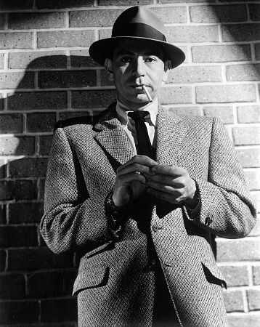

His real name was not Joe Friday, nor was it Pat, Jeff, Pete, Buzz-saw Louie or even Jack. He was born John Randolph Webb on April 2nd 1920 in Santa Monica California with a special gift that would be discovered later on and enjoyed for many years. One of the West Coast’s most consistent and sought after radio actors of that age, Mr. Webb could do many things, and do them well. Since his illustrious career is longer than my left leg, we shall focus mainly on his old time radio accomplishments where “Jack” (the name he went by) left his legacy.

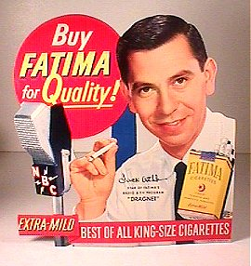

Jack Webb Served in WWII and started out in radio as a disc jockey before hosting, and acting in hundreds of old time radio shows. He had talent to be reckoned with and far off dreams of directing that eventually came to fruition in his well decorated career. His pedigree goes way back to the golden age of radio where it made its’ permanent gold mark before moving on to the medium that seemed to rudely push radio aside—namely television. Between radio shows he acted in old movies and eventually starred as Joe Friday on the famous television version of Dragnet. Webb ran the gamut of acting, producing and even directing-- fulfilling his dreams of old.

The spring of 1946 saw him doing several different shows from the West Coast on ABC. One of these was a Comedy-Variety program called “The Jack Webb Show”. Some People may not readily associate him with a funny show but this one had all the makings of a silly stage cast with the closing signature by Webb-“ Tonight’s egg was laid on the vocal side by Clancy Hayes and Nora McNamara. John Galbraith blew the lines and Dick Breen glued the joints together” (Dunning). The only apparent surviving episodes are full of fun and worth the listen. About the same time we can hear him with another type of script and on another stage—a stage with drama all over it. The show was a dramatic anthology called “Spotlight Playhouse”, and unfortunately has only a couple episodes in circulation. Both of these shows featured music and score by Phil Bovero. Another ABC drama called “Are These Our Children?” which originated out of San Francisco, aired an episode in November 1946 named “Edith Hayes” which had the expertise of Mr. Webb in the credits.

Before these shows though we can hear Jack showcase his talent in a documentary drama called “One Out Of Seven”. Each story for the show was chosen from actual news that happened the past week. Hence one story from the past seven days was picked; the scripts were fleshed out by James Edward Moser. This particular program stood up for what was right and hailed a voice that would not stand for racial prejudice. Jack Webb’s genius was proven as he played all roles and characters for this show and seemed to do them with such effortless ease. Jack Webb would be pro early on in his career.
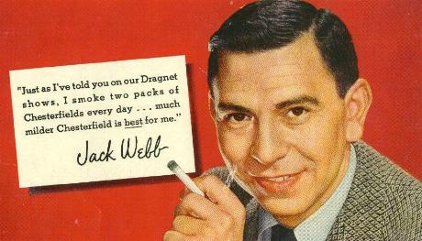

There were other shows that capitalized on Jack Webb’s ability in his early years in radio. The Red Cross had a syndicated 15 minute drama called “Errand of Mercy” that ran in the 1948-1949 timeframe with Jack in the line-up. At the same time the Treasury Department ran a syndicated show called “Guest Star” that penciled Jack in a handful of roles. On at least one occasion we see the episode date of these two shows with Jack’s name in the credits on the same exact day.

Jack soon became “Pat Novak, For Hire”, which ran on the west coast only circa 1946-47 on ABC. This was a crime drama that slapped a persona on Webb that would follow him for a long time in Radio. He was a tough, clever and quick witted detective full of one liners. You have to love this guy—just listening to him think will bring many laughs and much enjoyment. Even when a gun is pointed at him, the calm one liners flowed like a river after a big rain. Jack left the show and moved south, but since Pat Novak was so popular, the network re-cast that show and kept it on with a new lead and script writer. The show resurfaced in February 1949 nationwide with Webb back in old form.

After Jack left San Francisco for Hollywood, a new Detective adventure show began called “Johnny Madero, Pier 23”, which ran on Mutual from April through September 1947. This show is entertaining and reminds me of Phillip Marlowe in its descriptive writing style. Among the many quips you will here Johnny say are “Your so scary, I bet your dandruff stands on end” , “You couldn’t clear your throat in an empty tunnel”, “Some days your not gonna make out better than an ice cube at a cocktail party”, and ” Breaking more records than a disc jockey with a hangover”. This show had Gale Gordon and William Conrad in it with a familiar name writing the scripts—Richard Breen. Richard and Jack had worked together on most of his shows to this point. They (Breen and Webb) wanted to continue with Pat Novak but it was being carried on up north by Ben Morris and Gil Doud, so apparently, as the story goes, they started the Johnny Modero, Pier 23 show in the same spirit as Novak.(Dunning)

Jack frequently starred in many popular mystery and drama series like Escape, Suspense, and The Whistler, doing his thing in these series dozens of times. He was a busy guy that anyone would want on their cast. By 1948 you could see his name in the credits on “The New Adventures of Michael Shayne” before his debut as “Jeff Regan, Investigator”. By the time Regan aired, Jack Webb had a following of people who missed the Pat Novak days and wanted to hear Jack on the air again. “Jeff Regan, Investigator” was Webb’s third detective show before Dragnet’s creation and had a lot going for it from the get go. Even though this show was different than Webb’s previous detective characters, it did have a very prolific script writer in E. Jack Neuman and ran on CBS.

There were other ventures that Jack Webb had his hands in. Command Radio Productions hatched an idea for a show called “Three For Adventure” that had Elliot Lewis, Barton Yarborough and Jack Webb starring in the audition. This was to be an adventure series that apparently had the likeness of Carlton E. Morse’s famous “I Love a Mystery” series. As to what became of that program, the author has no idea but the audition show does exist. Other crime dramas in the “40’s” that had Jack in a role, were “Ellery Queen”, “The Adventures of Sam Spade” and the “Murder and Mr. Malone” series (which is also known by three other names).

In 1948 he starred in a movie called “He Walked By Night”, playing a crime lab police officer. It was on that set where he met sergeant Marty Wynn of the LA Police who happened to be the films technical adviser. As they discussed various aspects of investigative procedure and melodrama the idea for Dragnet was sown in the head of Jack Webb. He thought about creating the show with realism at the core and the stories to be authentic in every sense, using genuine police files. At that point Jack began hanging out with the police, attending classes at the police academy and riding along with them on calls. “Dragnet”, began its steady march of the airwaves in June 1949 and ran until February 1957. This would be Webb’s Magnum Opus in radio and followed into a more than one television series. Jack Webb played Detective Sergeant Joe Friday of The Los Angeles Police Dept. and also directed the series.
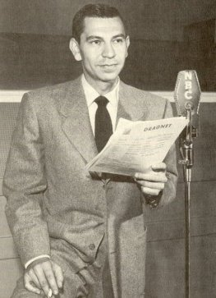

When the time came to pitch the show to NBC, they were unimpressed, thinking it would be just another cop show (Dunning). Webb went to the LA Police for help. He pitched the idea to them as well, wanting the stories to be real and from authentic files (with names being changed of course). Jack was a detailed professional and wanted nothing less than perfection on this one. The police approved and the show was successful beyond any other detective show in history. It won the coveted “Edgar” award for best drama two years in a row (1951-52) by the Mystery Writers of America and would forever be a show to be remembered. No other old time radio show could share the same repeat winning credits as this awarded program did.

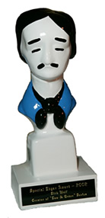
By the time the 50’s rolled around, “Dragnet” was a household name and the desire for Jacks Services was as strong as ever. He played a cynical police lieutenant in an episode of “The Story of Dr. Kildare”, along-side the great Lionel Barrymore, and also spot starred in classic shows like “Nightbeat”, and “Family Theater” and can even be heard in a show named “Proudly We Hail” circa 1952. His voice was on many channels during the prime of his career.

Two some odd years after Dragnet became a hit, Richard Breen created a new show called “Pete Kelly’s Blues” with Jack as the lead, and ran for 12 weeks on NBC. This show was set in the roaring twenties and featured Jack Webb as a cornet player in a speak-easy in Kansas City. The writing was similar to his old detective characters in some ways as he thinks much the same way and the language in his head sounds oh so familiar. The setting and music theme seemed to be its biggest charm and even led to a film of the same name in 1955 played by—you guessed it—Jack Webb. Fortunately most of this show’s run has been saved and is very enjoyable.

Jack Webb was not only an American, but also a patriot who loved his country. Many times he would do specials that would reflect these beliefs. In July 1957 he did the Fifth Anniversary Salute of “Operation Skywatch” which featured the U.S. Air Force Band. Another special, “Hollywood Salutes the National Guard” which was done in February 1959 had his help as well. The Air Force reserve had a syndicated show called “Weekend Sound Flights’63”, that had Jack as the announcer for at least three consecutive shows in 1963 and to round off things, he did a show on Mutual in 1969 called “Special Delivery: Vietnam”.

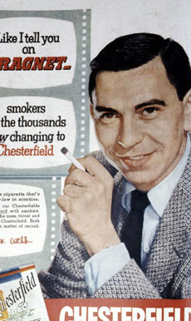

The list of credits goes on of course. Lots of celebrities had Jack on their shows throughout his acting tenure. From Bob Hope, Martin & Lewis and even to Jack Benny’s second farewell special in 1974, we can see that Jack Webb was respected and loved by fans and famous folks as well. He was nominated for an Emmy four times, authored a book and has his own star on the Hollywood walk of fame. He passed away in December 1982 but much of his work is preserved and enjoyed to this day. Jack Webb lives on!

