A NOTE ABOUT THE OPENING ANNOUNCEMENT
OF THE 1949-04-17 WHISTLER PROGRAM, “SLEEP MY PRETTY ONE”

This next show was broadcast during an important part of radio history. Most of us have never heard of this news event, but have probably seen the movie Radio Days by Woody Allen. One of the plotlines is how radio united the country with reports of the attempts to rescue a young girl who had fallen down an abandoned well. In the movie, the girl is named Polly Phelps, but in real life she was Kathy Fiscus.

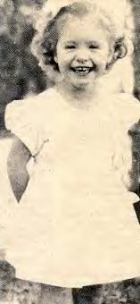

Details of the event can be found through Wikipedia en.wikipedia.org/wiki/Kathy_Fiscus . The article notes that it was a major event in television history, as cameras were moved to the site for reporting. But in 1949, while television was growing rapidly, buying one was still an expensive family enterprise, so most people would have learned about the events through newspapers and radio news.

The official date of death was determined to be the day she fell into the well, April 8, but the attempt to rescue her went on for three days.

Wikipedia mentions a song by Jimmie Osborne "The Death of Little Kathy Fiscus" of which half of the proceeds went to the family. It was claimed that 1,000,000 copies of the recording were sold. (Osborne committed suicide at age 34 in 1957; more details are at http://www.hillbilly-music.com/artists/story/index.php?id=11084 and http://obscurecountry.com/kathyfiscus.html; more on Osborne and a link to the song are at http://obscurecountry.com/osborne.html)

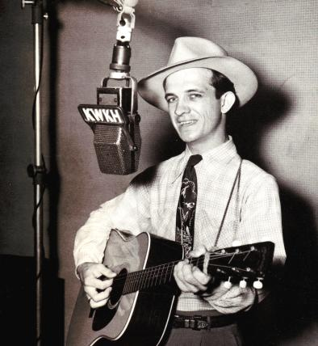

There do not appear to be any circulating copies of news broadcasts of that day and its aftermath. There are many shows circulating for the affected dates, but this is the only one that mentions it, and it is a week later.

So now the question is why does the opening of this show mention the Fiscus Tragedy almost 10 days after? It appears that the CBS Pacific Network was covering the event, and lost its feed because of a technical problem. At the time, they decided to go to their regular programming and to cover it from the studio if there was any update. So the mention here is an apology for not covering the event live. Signal may have taken a lot of public relations heat about the possibility of their heartlessly insisting on airing their show rather than continuing with on-site coverage. So the mention is an explanation of what had happened with the broadcast of the week before.

Though the plot of this episode has nothing to with a little girl who dies from an accidental fall, it is somewhat haunting that the title of the show is "Sleep My Pretty One."

###

JWW 3/25/2011

