Signal Oil

It all began by a terrible freeze in the winter of 1921. An avocado, orange and lemon grower Sam Mosher had lost all his crops and was going broke. At this same time one of the largest oil fields ever found in CA. had just been discovered at Signal Hill near Long Beach. Sam Mosher along with many other curious people went to see what was going on. As Sam watched the wildcat wells being exposed he noticed all the fires at the tops and the natural gasoline that was going up into the atmosphere. He thought what if I could capture that stuff and sell it. It was all history after that. In this first week I will cover this part a little each day from 1922 to 1931. Below is a picture of what Signal Hill looked like in the 1920's.

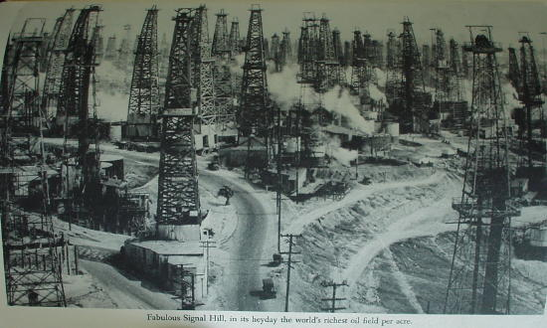

Most people think of Signal as the company with the stop light symbol. However, the first symbol was crossed flags like the ones pictured on the rail cars below.
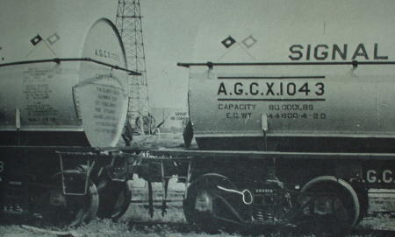

Sam Mosher had one problem with his idea to capture this natural gasoline he needed $4000 to get the idea running and one of the large companies let him tap into there well. So he borrowed towards his inheritance from his mother because his dad thought his idea was crazy. Shell oil company was the large company that let Sam Mosher use there well site. He got a couple college buddies together and off they go. Signal Products Company was born. They had no gas stations at this time and were just getting this natural gasoline which if run on it’s own produced large holes in engine pistons. Very high octane volatile stuff but when blended with gasoline would make great starting fuel in the winter and more power like adding ethyl.
Below are some signs and other Signal items from the collection of Fred Stoke.
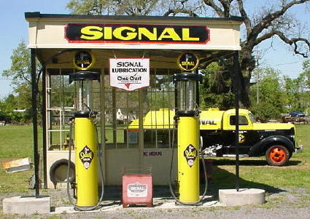
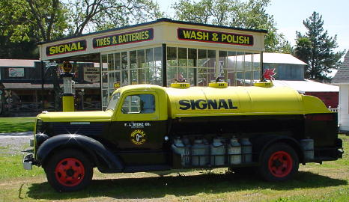
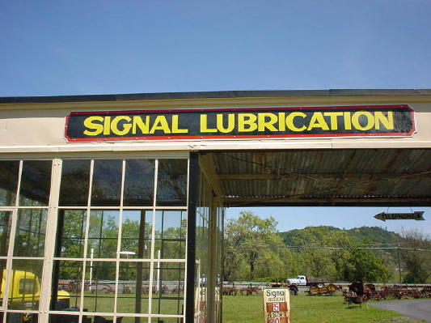
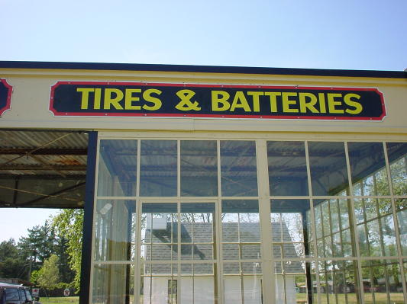

Around 1925-27 signal started producing greases and oils. They created a logo also with the signal on it, but used two colors to show what was being sold at different out lets. The Yellow was for greases. The black was for oils and sprits = kerosene's and lamp fuels. I was told by an old timer they had globes 16" in both the yellow and black logos that hung under the store fronts. The glass was flat and non baked paint was used so the paint over time burnt off. These logos was used on everything, boxes, lubsters, tanks for there fuels,
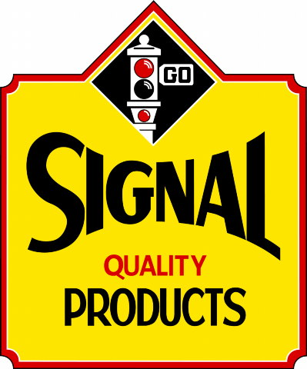
As this picture of my stack of Signal Grease cans show, Yellow was the color of their Greases, these cans and logo were used up until about 1937.
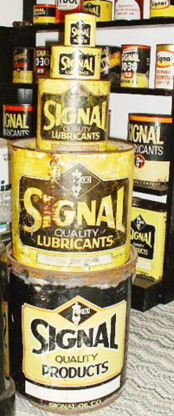
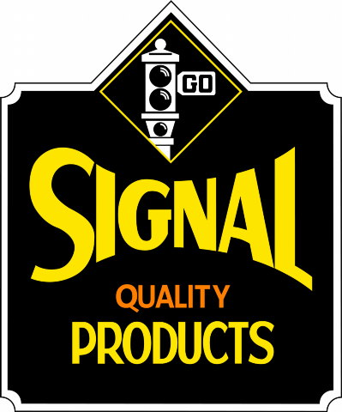
This decal logo was their first to be used on Lubsters , later = 1930 was redone to be used on their first quart can. with out the diamond signal emblem. if you will notice the inner circle on the logos and the same corners on all strip signs until 1959 when they changed there logo to the oval.
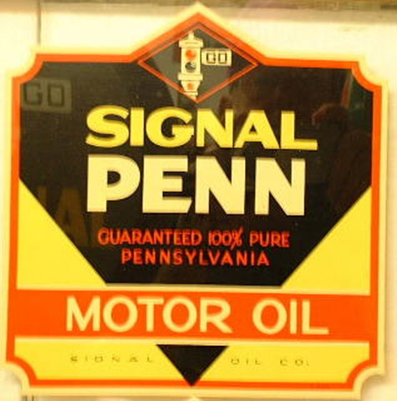
This globe replaced all the old non baked product globes in 1931 with the grand opening of there chain of filling stations.
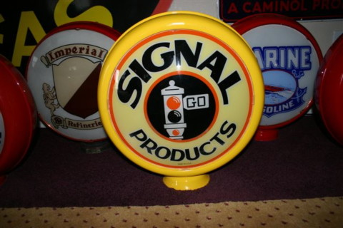

The story goes on. The depression hits and a lot of companies are going down. Not Signal, time to expand into the gasoline sales. In 1931 they bought out a small independent with the Purr-Pull gasoline. This was the United States Refining Company Limited. Wait a minute we don't really have a symbol that will sell gasoline so guess what? Let's use a stoplight get it, Signal Gasoline. So while other companies are folding Signal moves ahead. Like buying stock after a huge decline, it's got to get better. Below are shown the symbols Signal used.
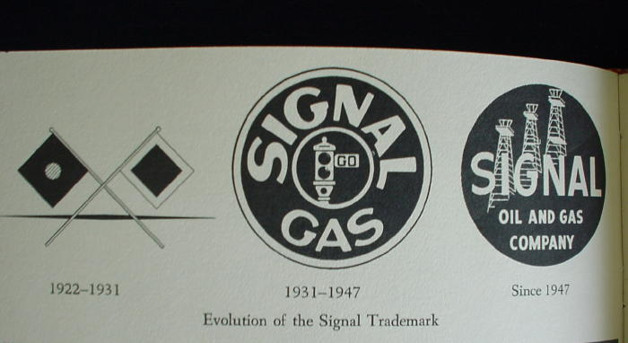
The symbol and the go farther caption is used. Nice art work.
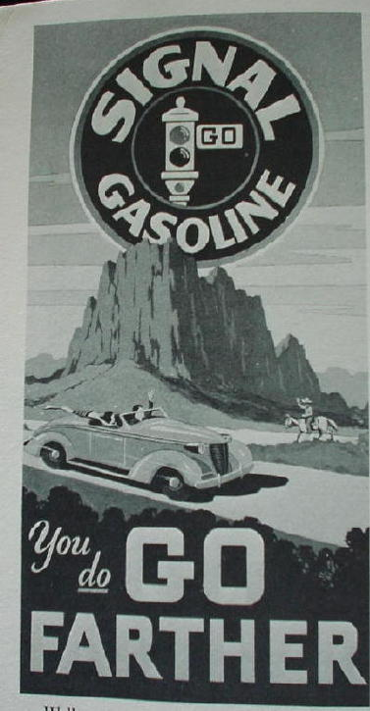

1931, Saw the grand opening of all the stations on one day. the globes were very plain, they had two, but at that time there was really only two types of low-compression engines, but that changed one year later, 1932 the V-8
higher compression. So Signal needed another type of fuel not just regular and ethyl. as all did they came up with a higher octane that became their Ethyl , Anti-knock and Regular, so they came out with new globes.
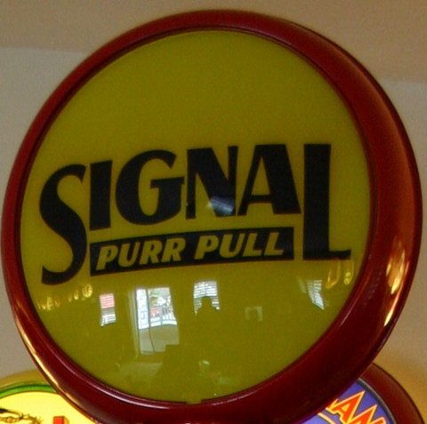
This is the first globe they used as their Ethyl. The Purple was used as their regular.
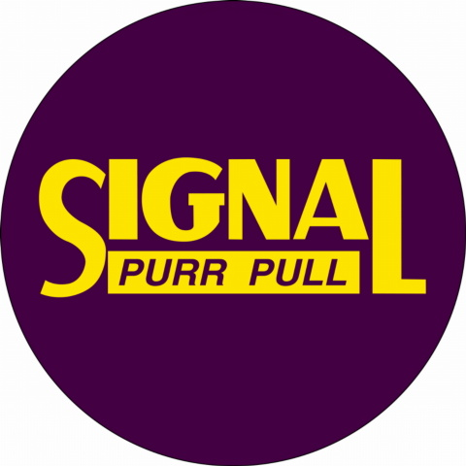
in the early times the globe didn't always show the type of fuel , it was the decal, these are as close as we can get using a black and white photo.
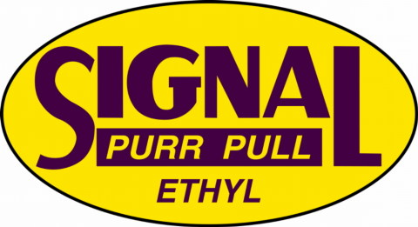
And since they started with only about 7-9 filling stations, no wonder these globes are gone. Here is the regular decal.
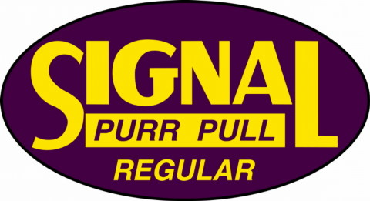

In 1931 along with getting the service stations going Signal contracted with Standard oil to provide natural gasoline and crude oil. Standard did not own Signal and was just a business partner. At this same time Signal got into a huge advertising agreement with radio and took over the radio program called Carefree Carnival soon to be renamed Signal Carnival a Sunday night weekly program. Also in 1931 Signal contracted the rights to use the popular movie Tarzan to attract the youth. Let's see?? Use the kids to influence the parents to buy Signal gas because of a special club. Below is some advertising dealing with the Signal Tarzan Club.
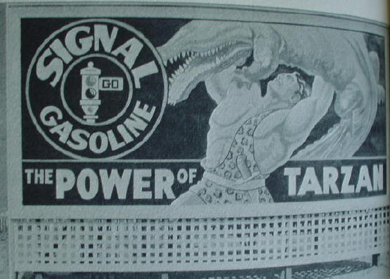
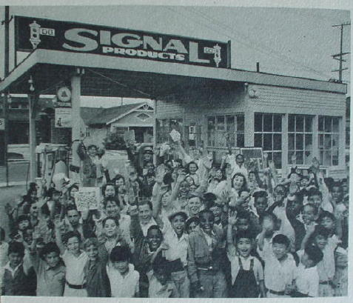

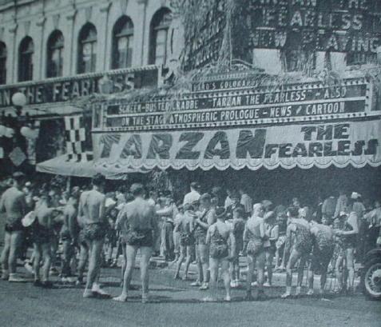

Below we have an official Tarzan Club card.
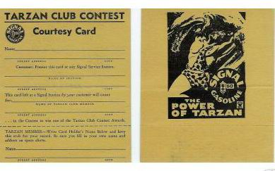
Advertising road bill boards were used all over California Oregon and Washington like the ones below.
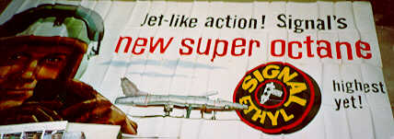
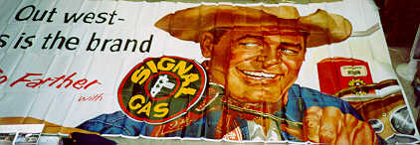
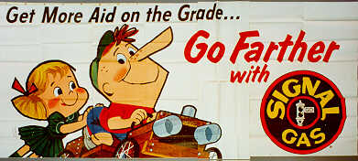
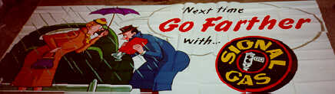

The Signal Tarzan club got to be so big they had to drop it after 5 years. Here’s an image of the Tarzan Pinback you got with the membership.
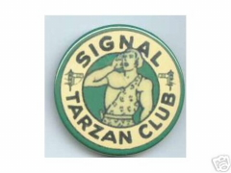

1931 to 1947. The company now has gasoline stations going and producing motor oil. They have moved east to Texas where they started tapping into oil wells for more natural gasoline. They will also have refineries in Texas. I wanted to do oil containers for pictures this week. The first picture below is one of the first quarts the company came out with.
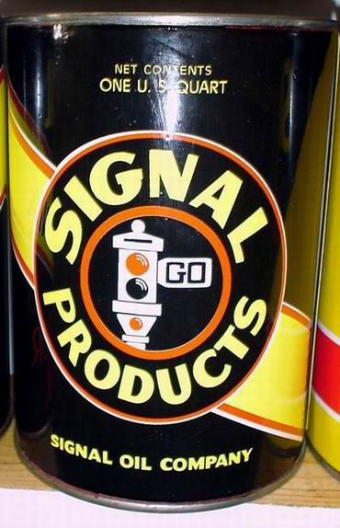
The picture below is some glass quarts from the collection of Fred Stoke.
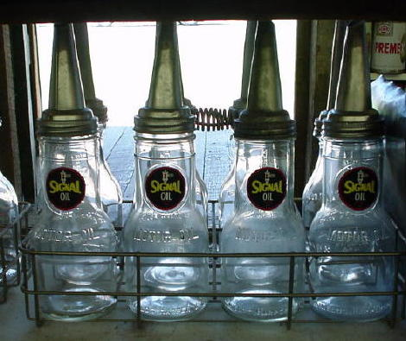

During WW II the Japanese actually were lobbing high explosive shells at Richfield and Signal oil fields in Southern CA. No damage was done but none the less the U.S. had shells fired on our homeland. Shells also were fired near Astoria OR. So Signal made it through the war and remained a strong independent. Pre war and depression advertising took on the theme of economy and inexpensive. After the war performance was stressed. The Go Farther theme advertised quality and performance. On Aug. 8,1947 Standard oil company took over the marketing outlets of the Signal oil and gas company but Signal kept all the drilling operations and changed there symbol to the half red and half black with the oil derrick in the middle. Standard had the service stations bulk plants advertising symbols but the Signal Company was still and independent oil company. Six months later Signal was back in the retail business and bought out the Craig oil company in southern CA. and opened 17 multi-pump stations. Signal now was concentrating on large stations and not the small neighborhood stations. Confusing , yes it is. Signal changed and got out of the retail oil business in late 1964 into 1965.
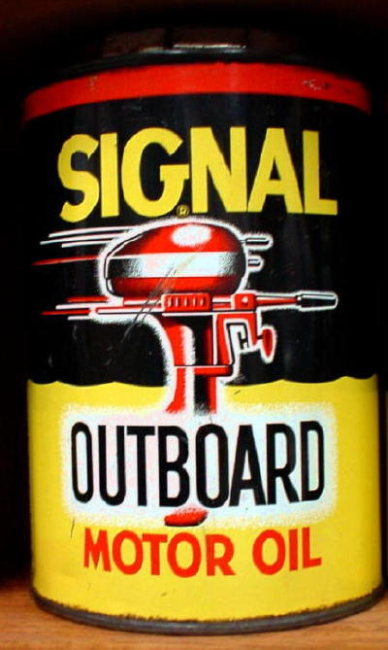
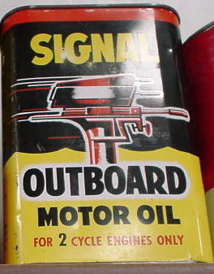

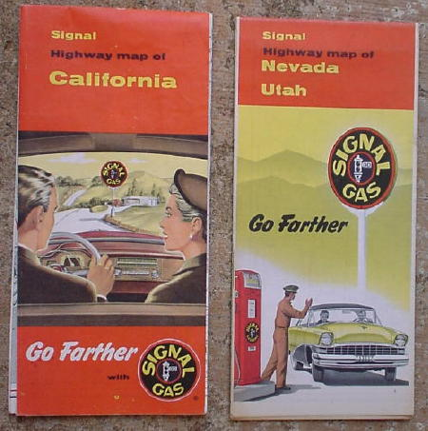

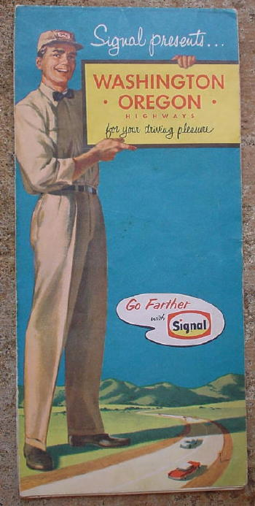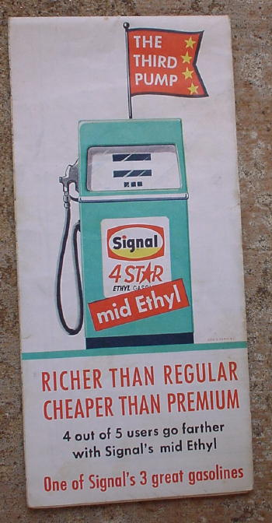

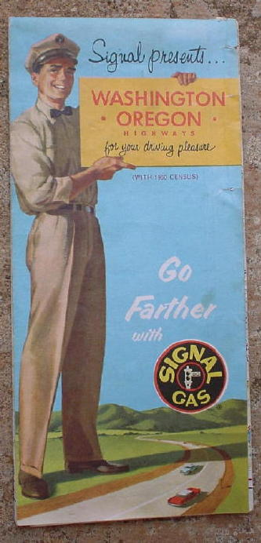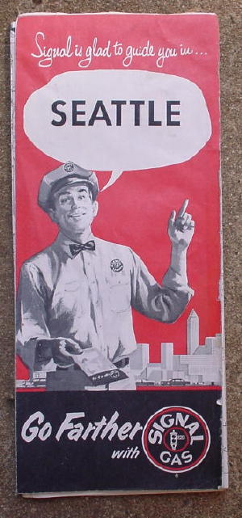

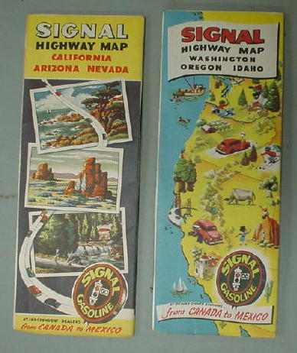

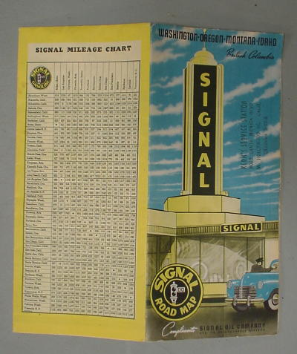

In 1958 there was a large fire at the Hancock plant in southern CA. This is when Signal Oil Company bought the Hancock Company. Several other independents were bought out through the 50's. Below are some of them.

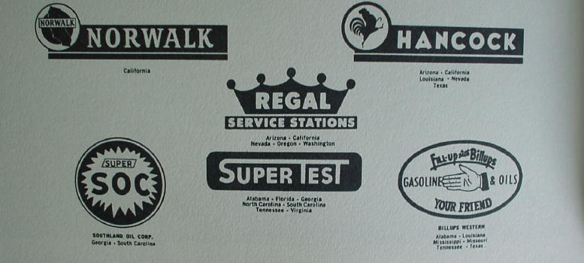

Here is a mileage book giveaway by the Signal Oil Company.
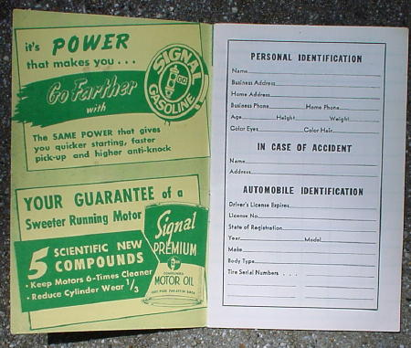
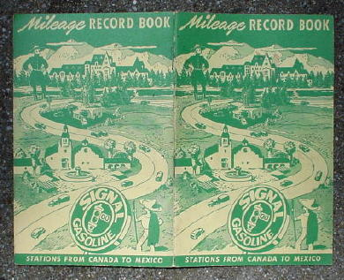

From 1947 to 1965 Signal was involved throughout the U.S. in oil drilling to refineries, retail and LPG. Below is a giveaway calendar that the company used.
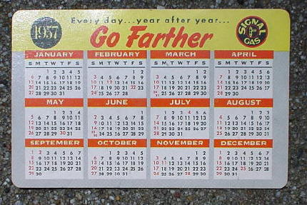
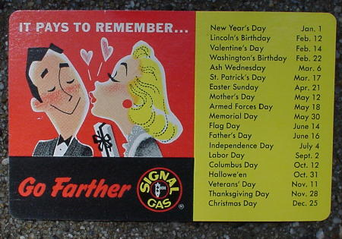

In 1963 Signal Oil Company merged with the Garrett Corp. manufacturer of missile components and other space age devices. This is where the design for the last oil cans came from.
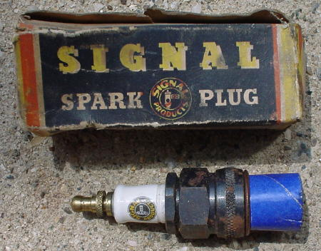

In 1965 Signal had closed it's retail gasoline business and was sold out to Enco out here on the west coast. Out of the gasoline business but not out of business. The space industry was where their efforts went. If you look at any FRAM oil filter you might see Signal Co. on it. Is it the same Signal Comapny that used to sell gasoline. I have been told it is. Believe it or not.
Below is a rare picture of the first Sign used for Signal Gas in 1931. Anyone who has this sign has a rare piece.
